

Risk Management Policy



If you require this information in an alternative language or another format such as large type, audio cassette or Braille, please contact the Pensions Help & Information Line on 01609 536335

Index
Index 2
1.0 Introduction 3
2.0 Risk management definition 3
3.0 Risk objectives of the fund 3
4.0 Benefits of risk management 4
5.0 Approach to risk management 4
5.6 Review 5
5.7 Risk Appetite 5
5.8 Responsibilities 5

1.0 Introduction

  - North Yorkshire Council (NYC, the Council) is the statutory administering authority for the North Yorkshire Pension Fund (NYPF, the Fund), which is part of the Local Government Pension Scheme (LGPS). All aspects of the Fund's management and administration are overseen by the Pension Fund Committee (PFC), which is a committee of the Council.

  - The primary objective of the Fund is to provide retirement benefits specified by the LGPS regulations for staff working for local authority employers, and other employers admitted by agreement, in the North Yorkshire area. Investments of the Fund are selected with the aim of fully funding these benefit requirements over an extended number of years.

  - The day to day running of the Fund is delegated to the Treasurer, who is also the Corporate Director Resources of the Council. The Treasurer is responsible for implementing the decisions of the PFC and is supported by specific teams within the Council. All aspects of the day-to-day management of investment funds are undertaken by external fund managers.

  - Risk, uncertainty and change create challenges to the Fund meeting its objectives. Risks, whether recognised or unforeseen, create a threat to achieving performance targets and change. Uncertainty and change, when considered thoroughly however, can also provide the opportunity to introduce new, innovative and effective ways to manage the Fund.

  - This Risk Management Policy has been developed by officers of the Fund and sets out the Fund’s strategic approach to effective risk management. The Policy is to be approved at least every 3 years by the PFC, as responsibility for the Fund’s risk management rests with them.

2.0 Risk management definition

2.1 A ‘risk’ is the chance or possibility of loss, damage, injury or failure to achieve objectives caused by an unwanted or uncertain action or event.

2.2 ‘Risk Management’ is the approach to managing all of the Pension Fund’s key service risks and opportunities with the aim of maximising service delivery effectiveness and efficiency. Risk management is critical to the overall management of the Pension Fund, including the management of staff, physical assets and financial resources.

2.3 Risk management is not about being ‘risk averse’, it is about being ‘risk aware’. The Fund recognises that it is not necessary to eliminate risk entirely, risks are necessary to achieve the objectives of the Fund, for example, investment return targets. It is important to weigh up the risk against the opportunities that can be gained.

3.0 Risk objectives of the fund

3.1 The Fund’s risk management objectives are:

- to continue to embed risk management into the culture of the Fund and all of its day-to-day activities
- to manage risk in accordance with best practice and support well considered risk taking
- to aim to reduce the overall cost of risk to the Fund
- to continue to raise awareness of the need for risk management with all those involved in the management of the Fund
- to maintain a robust framework and processes for identifying risks and their likely impact to inform the decision making of the Fund

4.0 Benefits of risk management

4.1 It is expected that if the Fund objectives above are being met that the following benefits will be realised:

- an established and reliable basis for decision making that can be justified
- improved governance of the Fund
- enhanced financial control of the Fund
- strengthened ability to meet the key objectives and targets of the Fund
- improved service for the members of the Fund
- supports innovation and allows the flexibility to be responsive to change
- avoids surprises and minimises loss and waste
- improved reputation of the Fund

5.0 Approach to risk management

5.1 Risk management is integral to all aspects of the management of the Fund. The Fund is committed to embedding risk management in all decision making. As such risk management is reflected in all of the Fund’s policies, including the following key policies:

- Investment Strategy Statement
- Funding Strategy Statement
- NYPF Annual Report and Accounts

5.2 The Fund operates within the risk framework of the Administering Authority. A Pension Fund Risk Register has been established that feeds into the Council’s Risk Register. This Risk Register identifies and analyses the risks faced by Fund. It covers a broad range of risks including both strategic, investment related risks and operational risks.

5.3 The Council’s standard risk evaluation approach has been adopted by the Fund to allow risk prioritisation and effective allocation of resources. Once risks have been identified and included on the risk register they are assigned a risk ranking, which will be red, amber or green. The ranking matrix is shown in the table below:

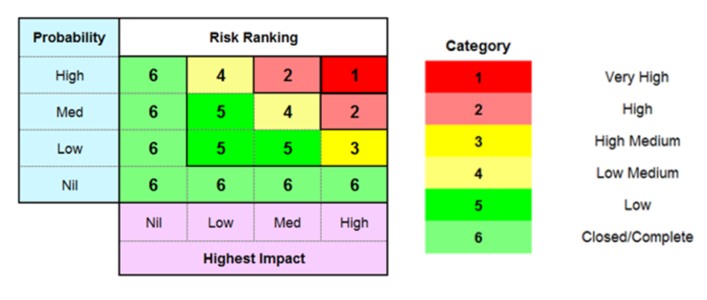

5.4 Each risk is ranked based on the following:

- existing risk controls in place
- probability of the risk occurring (based on existing controls)
- impact of the risk occurring (based on existing controls)
- further risk controls which may reduce current probability or impact

5.5 The probability and impact/severity of each risk is measured using High, Medium and Low categories based on thresholds set for each category. These thresholds are reviewed periodically to ensure they remain appropriate. The impact of risks occurring is split into the following 4 distinct areas:

- failure to meet key objectives
- financial impact
- service delivery
- loss of image or reputation

5.6 Review

5.6.1 The risk register is reviewed twice yearly in a risk workshop, attended by Pension Fund officers and officers from the NYCC Risk Management Section, to reflect changes in activity and in market conditions. An overarching risk, considering key Pension Fund risks, is also included on the NYCC Strategic Resources risk register which is reviewed twice yearly by the Corporate Director- Strategic Resources.

5.6.2 The Risk Register is also taken to the Pension Board every 6 months for review and is approved annually by the PFC. As with all of the Fund’s governance documents; the risk register is also reviewed annually by the Fund’s Independent Professional Observer.

5.7 Risk Appetite

5.7.1 The Fund accepts that it will face risks in order to achieve its objectives. However, it will not tolerate those risks which are assessed as having a high likelihood of causing a substantial impact on its financial position or services and/or lead to widespread member or employer complaints (category 1 risks in the table above). Any such risk identified will need to have a risk reduction plan developed and monitored by the PFC and implemented by the risk manager in order to ensure that the risk returns to a tolerable level within an acceptable timescale.

5.8 Responsibilities

5.8.1 The responsibility and accountability for managing the risks within the Pension Fund lies with the PFC.

5.8.2 Officers involved in the daily management of the Fund are also integral to managing risk for the Fund, and will be required to have appropriate understanding of risk management relating to their roles.

5.8.3 Advisers and suppliers to the Fund are also expected to be aware of this Policy.

April 2025

