

Governance Roles and Responsibilities

April 2025



If you require this information in an alternative language or another format such as large type, audio cassette or Braille, please contact the Pensions Help & Information Line on 01609 536335

Fu
As recommended by the Pensions Regulator, this document clarifies the roles, responsibilities, decision-making, governance structures and processes for the Local Government Pension Scheme (LGPS) administered by the North Yorkshire Pension Fund (NYPF). It also sets out the escalation procedures in the event of a breach of statutory requirements for the administration of the LGPS and relates to:

• North Yorkshire Council (NYC) as the Administering Authority for the NYPF
• Employers who participate in the NYPF as a statutory requirement or are admitted in certain circumstances
• Contractors who have service contracts with the Administering Authority or Scheme employers.

Roles and Responsibilities
The following chart sets out the relationships between the parties and the commentary below provides further details.

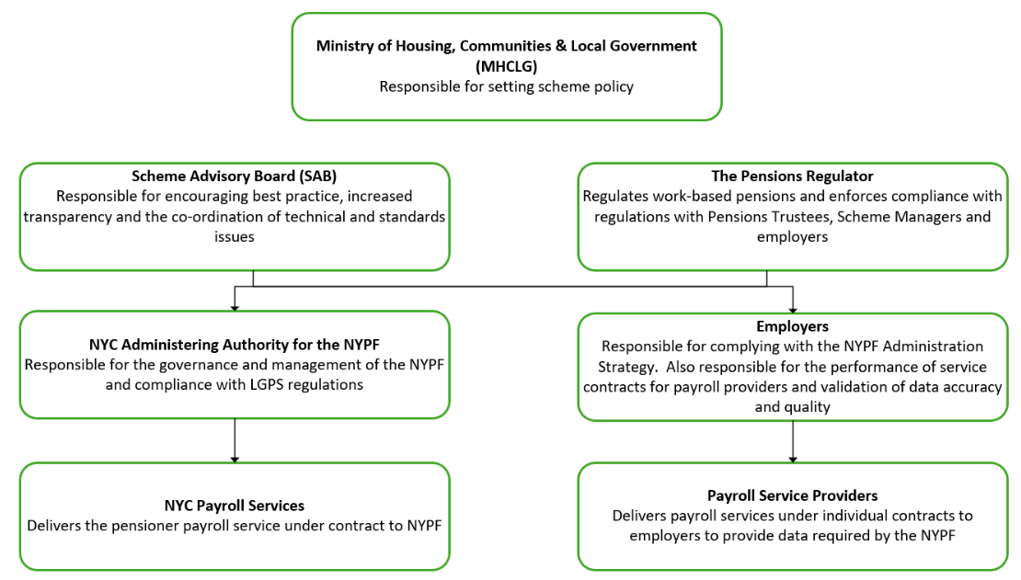

Body | Responsibility | Delivered by
Ministry of Housing, Communities and Local Government (MHCLG) | Setting out scheme policy | - Set out scheme policy in regulations, including the role of the scheme manager, Pension Board and Scheme Advisory Board
Scheme Advisory Board (SAB) | Responsible for encouraging best practice, increased transparency and the co-ordination of technical and standards issues. | - Considers items passed from DLUHC, the SAB’s sub committees and other stakeholders as well as items formulated within the SAB  - Liaison role with the Pensions Regulator  - Creation of guidance and standards for local scheme managers and Pension Boards
The Pensions Regulator | Regulates the governance and administration of work-based pensions and enforces compliance with regulations with Pensions Trustees and employers.  The Pensions Regulator’s objectives are to:  - improve confidence in work-based pensions.  - promote good administration.  - maximise employer compliance with regulations and employer duties | - Providing regulatory guidance and codes of practice setting out requirements  - Working with central government to embed regulatory changes for pension reforms  - Supporting the development of policy initiatives  - Monitoring performance  - Enforcing compliance  - Applying sanctions and or penalties on Trustees and employers for non-compliance
North Yorkshire Council  (Administering Authority for the  North Yorkshire Pension Fund) | Responsible for the governance, management and administration of the NYPF and compliance with LGPS regulations.  Responsible for investment decision making including managing Pooling arrangements.  Also responsible for the performance of the pensioner payroll service contract with NYC’s Payroll Services. | - Managing and governing the Pension Fund through NYC’s Pension Fund Committee (PFC) and Pension Board  - Providing a framework of policies and procedures for compliance with the LGPS regulations  - Reporting on compliance and performance to the Pensions Regulator  - Monitoring performance of NYC’s Payroll Services contract  - Monitoring performance of employers  - Applying sanctions and or penalties on employers for non-compliance  - Reporting breaches of regulations to the Pensions Regulator
North Yorkshire Council  Payroll Services | Responsible for delivering pensioner payroll services to the NYPF under a service contract. | - Delivering the pensioner payroll service under contract to the NYPF  - Providing pensioner payroll guidance and support to the NYPF and Scheme members

Body | Responsibility | Delivered by
Scheme Employers | Responsible for working within the NYPF’s policies and procedures to ensure compliance with LGPS regulations.  Also responsible for the performance of service contracts for payroll services and validation of data quality. | - Complying with the policies and procedures for the administration of the LGPS scheme for employees  - Monitoring performance of outsourced service contracts providing data to the NYPF  - Validating the quality of data submitted to the NYPF  - Ensuring outsourced service contractors meet the quality standards and submission deadlines
Payroll Service Providers | Deliver payroll services under individual service contracts to employers | - Provide payroll services in compliance with the service contract with the employer  - Ensure that employer instructions are actioned for the provision of data to the NYPF  - Ensure that data provided meets quality standards and is submitted within deadlines  - Ensure that the employer validates the data before submission to the NYPF

Pension Fund Committee and Local Pension Board
Expectations of the Chair

The Pensions Regulator’s (“the Regulator”) General Code of Practice sets out the skills and behaviours it expects the Chair of the PFC and the Chair of the Pension Board to demonstrate, as a matter of good practice. However, the Regulator does not expect a higher standard of knowledge from the Chair.

The skills and behaviours outlined below:

- Act as the leader of the governing body and demonstrate the standards of behaviour expected from other members of the PFC and Pension Board.
- Represent the interests of the scheme to all relevant parties, including employers, advisers, service providers, and scheme members.
- Have an independent viewpoint when necessary and be able to manage potential conflicts.
- Be able to recognise each individual’s potential, and ensure their knowledge and skills are used effectively.
- Encourage PFC and Pension Board members to think strategically and take a broad, long-term view.
- Help achieve compromise and consensus to achieve good outcomes.
- Encourage participation from all members of the PFC and Pension Board, including new members.
- Be able to demonstrate elements of the following skills:
  - Communication with the governing body and its stakeholders.
  - Organising training either in-house or via external bodies.
  - Debating, challenging, and negotiating.
  - Ability to gather and understand diverse views.
  - Managing conflicts of interest.

North Yorkshire Council’s administration responsibilities

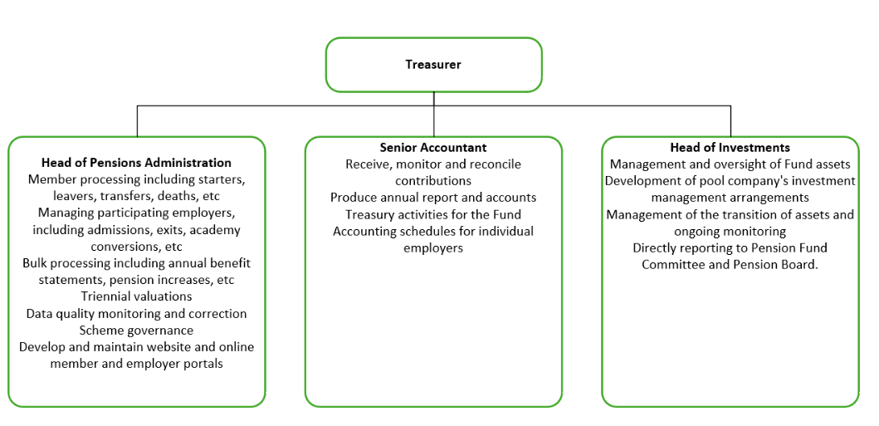

Escalation Procedures
To ensure that the NYPF meets its statutory responsibilities and obligations, it is important that all parties involved in pension administration carry out their responsibilities efficiently. The following sets out escalation procedures for non-compliance with pension administration requirements.

North Yorkshire Council  (Administering Authority for the  North Yorkshire Pension Fund) | - The Administration Strategy sets out performance standards for the Administering Authority and employers including chargeable penalties  - The NYPF will support employers to meet performance standards  - In the event that employers do not engage proactively to meet performance standards and deadlines then penalties will be imposed on employers for non-compliance  - For significant performance issues and breaches of the law, the NYPF will report events to the Pensions Regulator

