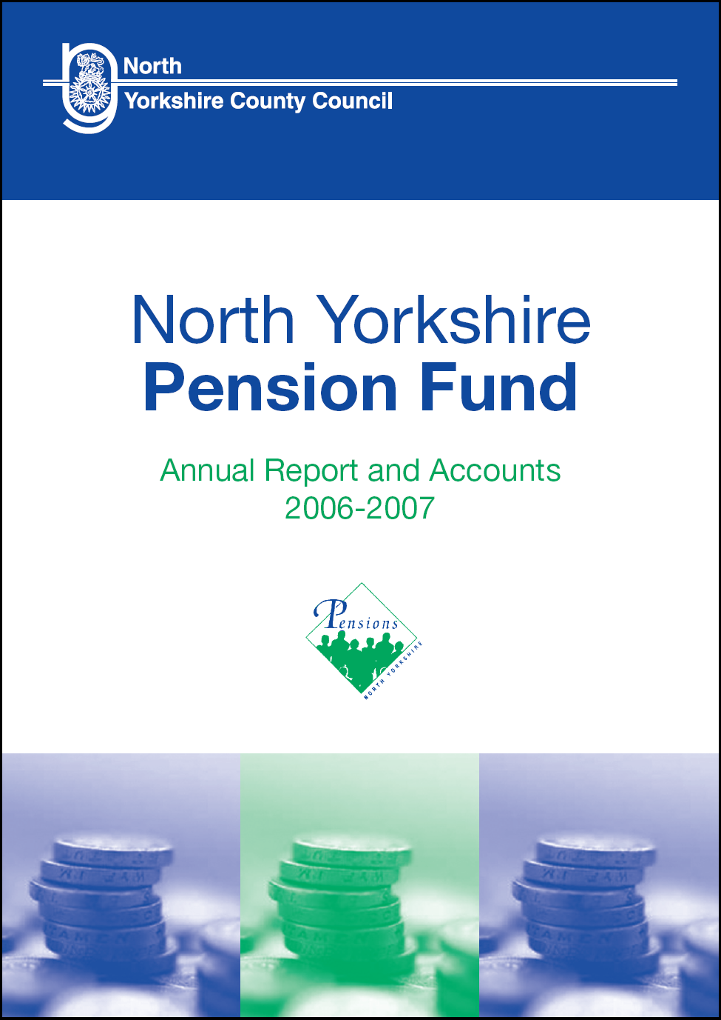
2012/13

CONTENTS

Item | Page No
PART 1 MANAGEMENT OF THE FUND | 3
PART 2 SCHEME ADMINISTRATION | 5
PART 3 INVESTMENT POLICY AND PERFORMANCE | 7
PART 4 PENSION ADMINISTRATION ACTIVITY | 11
PART 5 MEMBERSHIP CONTRIBUTIONS AND SCHEME BENEFITS | 13
PART 6 GOVERNANCE DOCUMENTATION | 18
Appendices
Appendix A Statement of Financial Accounts 2012/13 | 20
Appendix B Auditors Report | 46
Appendix C Statement of Investment Principles | 48
Appendix D Governance Compliance Statement | 54
Appendix E Funding Strategy Statement | 62
Appendix F Communications Policy Statement | 90
Appendix G Actuarial Rates and Adjustment Certificate | 96

PART 1 – MANAGEMENT OF THE FUND

1.1 Introduction

North Yorkshire County Council (NYCC, the Council) is the statutory administering authority for the North Yorkshire Pension Fund (NYPF, the Fund), which is part of the Local Government Pension Scheme (LGPS). All aspects of the Fund's management and administration, including investment matters, are overseen by the Pension Fund Committee (PFC), which is a committee of the Council.

The purpose of the Fund is to provide retirement benefits specified by the LGPS regulations for staff working for local authority employers, and other employers admitted by agreement, in the North Yorkshire area. The regulations also specify the member contribution rates as a percentage of pensionable pay, with employer contribution rates being set every three years by the Fund’s Actuary. These contributions are supplemented by earnings on the Fund’s investments in order to pay retirement benefits.

The day to day running of the Fund is delegated to the Treasurer who is the Corporate Director – Strategic Resources of the Council and is responsible for implementing the decisions made by the PFC. Supporting him is a team of staff split into two sections. The Pensions Administration team administers all aspects of member records, pension benefits etc and the Corporate Accountancy team looks after the accounting and management information requirements of the Fund. All aspects of the day to day management of investment funds are undertaken by external fund managers.

1.2 Pension Fund Committee

PFC membership as at 31 March 2013 was as follows.

Members | Position | Voting Rights
John Weighell (Chairman) | Councillor, NYCC | Yes
Roger Harrison-Topham  (Vice-Chairman) | Councillor, NYCC | Yes
Bernard Bateman MBE | Councillor, NYCC | Yes
John Blackie | Councillor, NYCC | Yes
Margaret-Ann deCourcey-Bayley | Councillor, NYCC | Yes
Patrick Mulligan | Councillor, NYCC | Yes
Helen Swiers | Councillor, NYCC | Yes
Jim Clark | Councillor, District Councils’ representative of Local Government North Yorkshire and York | Yes
Julie Gunnell | Councillor, City of York Council | Yes
Chairman of the NYPF Advisory Panel | Councillor, NYPF Advisory Panel representative | No
3 Unison representatives | Union Officials | No
Following Council elections on 2 May 2013, Julie Gunnell resigned from the PFC and was replaced by Dafydd Williams (Councillor, City of York Council), and Sam Cross (Councillor, NYCC) was also appointed to the PFC.

The powers delegated to the PFC are detailed in paragraph 2.1 of the Governance Compliance Statement (Appendix D).

During the year the PFC formally met on five occasions supported by its Independent Investment Adviser, Investment Consultant and the Independent Professional Observer, as well as the Treasurer. The Committee meetings provide a forum for discussion about economic and market trends, monitoring the performance of the investment managers and considering their individual investment strategies.

1.3 Fund Administrators, Advisers and Investment Managers

Treasurer Gary Fielding

Investment Consultant Aon Hewitt
Independent Investment Adviser Carolan Dobson (Investment Adviser &
Trustee Services)
Independent Professional Observer Peter Scales (AllenbridgeEpic)
Actuary Mercer
Legal Services Ward Hadaway
Head of Legal Services, NYCC
Auditor Deloitte
Banker Barclays Bank
Custodian Bank of New York Mellon
Custodian Monitoring Thomas Murray
Shareholder Voting PIRC
Performance Measurement BNY Mellon Asset Servicing

Fund Managers Amundi Asset Management
Baillie Gifford Life
ECM Asset Management
FIL Pensions Management
Hermes Investment Management
Legal & General Investment Management
M&G Investment Management
Newton Investment Management
R C Brown Investment Management
Standard Life Pension Funds
Threadneedle Pensions
YFM Venture Finance
AVC Provider Prudential

PART 2 – SCHEME ADMINISTRATION

2.1 Administering Authority Arrangements

The Fund’s administration is the responsibility of Gary Fielding, the Treasurer, who is supported by Tom Morrison, Principal Accountant Pensions & Projects and Nigel Dowey, Pensions Manager (Administration).

Staff within the Pension Administration section are responsible for administering the Scheme, including the calculation and administration of benefit payments and transfer values, recording employee and employer contributions, the maintenance of employees’ pension records and communications with employers and employees.

Staff within the Corporate Accountancy section are responsible for maintaining the Fund’s accounts and investment records, prepare quarterly reports to the PFC, produce the Annual Report and Accounts and act as a point of contact with the Fund’s managers, advisers and auditors.

2.2 Public Sector Pensions – Finance Knowledge and Skills

The PFC recognises the importance of ensuring that all Members and officers charged with the financial management, governance and decision-making with regard to the pension scheme are fully equipped with the knowledge and skills to discharge their duties responsibilities. The PFC also seeks to ensure that those Members and officers are both capable and experienced by making available the training necessary for them to acquire and maintain the appropriate level of expertise, knowledge and skills.

Following the issue of CIPFA guidance “Pensions Finance Knowledge and Skills Frameworks” the PFC provides routes through which the recommended knowledge and skills set out in the guidance may be acquired, as described below.

2.3 Training for Pension Fund Committee Members and Officers

- Internal

One Investment Strategy Workshop and six investment manager workshops were held throughout the year, all of which were well attended by PFC Members and officers of the Fund.

Members and officers also made use of the CIPFA Knowledge & Skills resource library and accessed the Trustee Needs Analysis (TNA) where appropriate, which is aimed at identifying gaps in knowledge and skills, as a complement to alternative training resources.

(ii) Externally Provided

In addition to the training provided through Workshops as described above, Members and officers are encouraged to attend courses, conferences and other events supplied by organisations other than the Council. These events provide a useful source of knowledge and guidance from speakers who are experts in their field. Attendance at these events is recorded and reported to the PFC each quarter.

Events attended by PFC Members during 2012/13 were:

Event | Place | Date
NAPF Local Authority Conference  BNY Mellon Alternatives | Warwickshire  London | 21-23 May 2012  6 July 2012
LGC Investment Summit | Newport | 6-7 September 2012
Fidelity Institutional Investors | London | 10 October 2012
NAPF Annual Conference | Manchester | 17-19 October 2012
LAPFF Annual Conference | Bournemouth | 28-30 November 2012
LGC Investment Conference | Chester | 28 February 2013
NAPF Investment Conference | Edinburgh | 6-8 March 2013

PART 3– INVESTMENT POLICY AND PERFORMANCE

3.1. Investment Policy

(a) Regulations

NYCC is required, as the administering authority, to invest any NYPF monies which are not immediately required to pay pensions and other benefits. The LGPS Management and Investment of Funds Regulations 2009 set out certain restrictions as to individual investments, the purpose of which is to limit the exposure risk of an LGSP fund. Full details of the investment policy are shown in the Statement of Investment Principles (Appendix C).

(b) Investment Management arrangements

As at 31 March 2013 the following investment management arrangements were in place.

- Baillie Gifford managed two active global (ie including UK) equity portfolios, namely Global Alpha and Long Term Global Growth (LTGG). Each of these portfolios is in the form of a pooled vehicle, rather than being invested in segregated holdings. Both are managed without reference to a benchmark, however the FTSE All World index is for used performance measurement purposes
- Fidelity managed an active overseas equities (ex UK) portfolio comprising segregated holdings in overseas companies against a composite MSCI World (ex UK) index
- Standard Life managed an active UK equity portfolio comprising segregated holdings in UK companies against the FTSE 350 (excluding investment trusts) equally weighted index
- Amundi managed an active global fixed income portfolio through a pooled fund, against the “least risk” benchmark of index linked and fixed interest gilts
- ECM managed an active European corporate bond portfolio through a pooled fund on an absolute return basis, using 1-month LIBOR for performance measurement purposes
- M&G managed an active Gilts portfolio comprising segregated fixed income and index linked holdings, against the “least risk” benchmark
- Hermes managed an active UK Property portfolio through a pooled fund with the objective of outperforming the retail price index (RPI)
- Threadneedle and Legal & General both commenced managing active UK Property portfolios during the year through pooled funds with the objective of outperforming RPI
- Standard Life and Newton both commenced managing Diversified Growth Fund portfolios during the year through the Global Absolute Return Strategy (GARS) and Real Return (RR) pooled funds respectively, with the objectives of significantly outperforming the cash benchmark

The Fund also has a small portfolio of assets (£2.7m) held by R C Brown Investment Management Plc. This equity mandate is based on ethical criteria and has been invested on this basis at the request of one particular employing body.

The Fund also has a small investment in the Yorkshire & Humber Equity Fund. The current residual cost of this investment is £0.5m.

Finally, a currency hedging account is operated directly with the Fund's global custodian, BNY Mellon Asset Servicing, in respect of 25% of the Fund’s overseas equities exposure to the major currencies.

The agreed asset class structure for the investment portfolio remained unchanged over the course of the year and as at 31 March 2013 was as follows:-

 | Minimum Allocation to Bonds/Alternatives/Property  % | Maximum Allocation to Bonds/Alternatives/Property  %
Equities | 75 | 50
Bonds | 15 | 30
Alternatives (ex Property) | 5 | 10
Property | 5 | 10
Total | 100 | 100

(c) Custody of Investments

BNY Mellon Asset Servicing is the custodian for the Fund’s assets. There are two exceptions, being:-

(i) Yorkshire and Humber Equity Fund, which uses the Royal Bank of Scotland plc

(ii) Internally Managed Cash, which is held either in the Fund’s bank account or is swept into the Council’s County Fund account, both held at Barclays Bank, Northallerton. In accordance with the Regulations a formal service agreement exists between the Council and the Fund so that the Fund receives an interest rate return equivalent to that achieved by the Council.

The main services provided by BNY Mellon are the custodianship of the Fund's assets, including settlement of trades and collection of income, investment accounting and performance measurement of the fund managers.

3.2 Performance

(a) Fund and Manager Performance

Fund performance is measured and assessed on a quarterly basis primarily by Mellon Analytical Services (MAS), a division of BNY Mellon. A second tier of analysis is provided by the WM Company for the purpose of assessing comparisons with the WM Local Authority Universe which comprises performance data of the vast majority other local authority pension funds. Performance of the Fund and individual managers is assessed relative to the defined benchmarks specified by the PFC.

Pension Fund investment is a long term business, so as well as considering the annual performance of the Fund, performance over extended periods in comparison to peers is also considered; this principle is applied both to individual managers and the overall Investment Strategy of the Fund.

The return produced by the Fund is a contributory factor in setting the employer contribution rates. The mix of assets within the Fund has been established to generate the greatest possible return within sensible limits of risk.

Performance for the year was +16.4% compared to the benchmark return of +15.3% and the local authority average (as measured by WM Services) of +13.8%. NYPF was ranked 8th out of 82 Local Authorities within the WM Local Authority Universe.

The performance of the Fund as a whole and of the individual fund managers for the year to 31 March 2013 compared with their defined benchmarks is shown in the following table:

Fund Manager | Share of Fund @ March 2013 | Fund  Performance | Customised Benchmark | +/-
 | % | % | % | %
Baillie Gifford Life Ltd - Global Alpha | 16.6 | 19.6 | 17.1 | 2.5
Baillie Gifford Life Ltd - LTGG | 9.7 | 9.9 | 17.1 | -7.2
FIL Pensions Management (Fidelity) | 20.3 | 17.5 | 16.3 | 1.2
Standard Life Pension Funds Ltd | 17.1 | 24.6 | 21.1 | 3.5
ECM Asset Management Ltd | 6.5 | 5.3 | 0.6 | 4.7
Amundi Asset Management  M&G Investment Management Ltd | 12.8  4.0 | 14.8  11.4 | 11.6  11.6 | 3.2  -0.2
Hermes Investment Management Ltd  Legal & General#  Threadneedle# | 1.3  1.4  1.0 | 2.9  -  - | 3.3  -  - | -0.4  -  -
Standard Life (GARS)#  Newton Investments (RR)#  R C Brown Investment Management Plc  Yorkshire & Humber Equity Fund  Currency Hedging | 4.4  4.3  0.2  0.0  -0.2 | -  -  8.0  -  - | -  -  16.8  -  - | -  -  -8.8  -  -
Internally Managed Cash | 0.6 | - | - | -
Total Fund | 100.0 | 16.4 | 15.3 | 1.1

# The initial investments with Legal & General, Threadneedle, Standard Life (GARS) and Newton Investments (RR) were made during 2012/13, therefore performance data for the year is not available

The Fund achieved excellent performance overall with managers representing 73% of total assets outperforming the challenging benchmark, which itself exceeded the local authority average by 1.5%.

(b) Accounting and Cash Flow

The Statement of Financial Accounts for the year 2012/13 is shown at Appendix A.

The value of the Fund’s assets at 31 March 2012 was £1,566m, and this increased by £275m during the year to give a value of £1,841m at 31 March 2013.

Prior to the start of the 2012/13 financial year, a Budget was prepared for NYPF which expressed the expected levels of expenditure (ie pensions, lump sums, administrative expenses) and income (ie employees and employers’ contributions, net transfer values in, early retirement costs recharged). The Budget was monitored at each subsequent quarterly PFC meeting, and revised as necessary to take into account the latest projections.

The revised Budget for 2012/13 forecast a net cash surplus of £18.1m, which compared with the actual surplus for the year of £16.8m, resulting in an overall cash flow of £1.3m below expectations.

 | Budget 2012/13  £m | Actual Income / Expenditure  £m | Variance  £m
Expenditure
Benefits | 84.0 | 84.6 | -0.6
Administration | 1.4 | 1.4 | 0.0
Investment Expenses | 4.5 | 3.6 | 0.9
Total Expenditure | 89.9 | 89.6 | 0.3
Income
Employer and Employee contributions | 105.0 | 105.8 | 0.8
Transfers | 3.0 | 0.6 | -2.4
Total Income | 108.0 | 106.4 | -1.6
Net Surplus | 18.1 | 16.8 | -1.3

The budget was set anticipating that the larger employers in the Fund would seek to reduce staffing levels in response to the Government cutting funding to public sector organisations, and that the shrinking economy would also affect the private sector. This has occurred, however the extent and timing of staff reductions was very difficult to predict, hence the variance on benefits payable and contributions from employers. In addition, the value of transfers equates to the net of transfer values for staff moving in and out of the Fund in the year and cannot be reliably predicted.

Investment income is received by the investment managers, and is reinvested accordingly and is therefore not included in the budget monitored by the PFC.

PART 4 – PENSION ADMINISTRATION ACTIVITY

The number of staff (in FTE terms) at the Council involved in Pension Administration was 24.

(a) Key Performance Indicators

The Local Government Pensions Committee has defined a range of performance indicators through which Pension Funds can be compared. NYPF’s performance in these areas for the year to 31 March 2013 is shown below.

Performance Indicator | LGPC  Target | Achieved (%)
Letter detailing transfer in quote | 10 days | 98
Letter detailing transfer out quote | 10 days | 100
Process and pay refund | 5 days | 100
Letter notifying estimate of retirement benefits | 10 days | 99
Letter notifying actual retirement benefits | 5 days | 100
Process and pay lump sum retirement grant | 5 days | 100
Initial letter acknowledging death of active/deferred/pensioner member | 5 days | 100
Letter notifying amount of dependant's benefits | 5 days | 100
Calculate and notify deferred benefits | 10 days | 98

These figures compare extremely favourably with other LGPS Funds, where the average achievement ratings for these performance indicators fall between 82% and 92%.

(b) Benefit Calculation Activity

The number of cases processed during the year requiring benefit calculations was as follows.

Task | Number
Retirements | 1,038
Transfers In | 100
Refunds | 58
Frozen Refunds | 150
Preserved Benefits | 3,569
AVCs/ARCs | 159
Divorce cases | 185
Deaths in Service | 26
Deaths of Pensioners | 304
(c) Administration Costs per scheme member

NYPF’s average cost of administration per member in 2012/13 was £14. This compares with the average cost per member in the comparative group of local authority pension funds of £21.

The total numbers of joiners and leavers during 2012/13 were:

Joining | 2,307
Retiring | 1,038
Deaths | 269
Other Leavers | 4,604

The performance, activity and cost effectiveness reflect the efforts the Pension Administration team goes to provide a first class service to the Fund membership. NYPF is one of the leaders across LGPS administering authorities in terms of communication initiatives and innovative use of technology. Examples of this over 2012/13 include:

- arranging for government experts to address employing authorities directly on the key issues facing them such as Auto-Enrolment and LGPS 2014. NYPF employers have been more promptly and more thoroughly informed and prepared for change than counterparts across the country
- notifying NYPF membership immediately of the Prudential's plans to implement exit charges. This enabled hundreds of members to make arrangements before the rush clogged up the system and frustrated plans of many members of other LGPS Funds
- continuing to develop self-service options for Fund members with particular emphasis this year on distributing individual PIN numbers and on convenient on-line Annual Benefit Statements
- implementing a customer helpline that provides a one-stop service for members without compromising the ability of Pensions Officers to take into account the specific circumstances of each individual joiner or leaver.

PART 5 – MEMBERSHIP CONTRIBUTIONS AND SCHEME BENEFITS

5.1 Membership

NYCC operates the NYPF for its own employees (excluding Teachers) together with those of the other local authorities within the County area, and certain other bodies eligible to join the Fund, under the terms of the LGPS regulations. The Fund does not cover teachers, police and fire-fighters for whom separate statutory arrangements exist.

Membership of the LGPS is not compulsory, although employees over 16 years old are automatically admitted to the Fund unless they elect otherwise.

Employees therefore have various options:-

- to be a member of the NYPF
- to be part of the State Second Pension Scheme, or
- to purchase a personal pension plan or a stakeholder pension managed by a private sector company.

The following table summarises the membership of NYPF over the past 5 years.

Membership Type | 31 March 2009 | 31 March 2010 | 31 March 2011 | 31 March 2012 | 31 March 2013
Current Contributors | 28,372 | 28,623 | 29,295 | 27,770 | 29,036
Deferred Pensions | 19,953 | 22,079 | 23,800 | 25,534 | 27,503
Pensioners receiving Benefits | 13,333 | 14,119 | 14,888 | 15,839 | 16,755

5.2 Contributions

The Fund is financed by contributions from both employees and employers, together with income earned from investments. The surplus of income received from these sources, net of benefits and other expenses payable, is invested as described in the Statement of Investment Principles (Appendix C).

For employee contributions a banded structure has been in place from April 2008 linked to the rate of pensionable pay a member receives. The band ranges were updated in April 2012 as follows:-

Band | Range | Contribution rate
1 | £0 to £13,500 | 5.5%
2 | £13,501 to £15,800 | 5.8%
3 | £15,801 to £20,400 | 5.9%
4 | £20,401 to £34,000 | 6.5%
5 | £34,001 to £45,500 | 6.8%
6 | £45,501 to £85,300 | 7.2%
7 | More than £85,300 | 7.5%

The employer has the discretion to decide how often the contribution rate is changed if the pensionable pay of the employee increases or decreases. This will usually be once a year, or where there are contractual changes to an employee’s post(s).

Employers’ contributions are determined in a cycle every three years by a Triennial Valuation. The Valuation assesses the contributions required to meet the cost of pension benefits payable as they are earned, as well as additional contributions employers may be required to pay to address any deficit relating to previous years. Further details, including a list of each employer’s minimum contributions following the 2010 Valuation for the financial years 2011/12, 2012/13 and 2013/14 are shown at https://www.nypf.org.uk/Documents/2010ActuarialValuationReport.pdf

Any new entrants to the scheme will be included on the 2013 Triennial Valuation report when it is published in March 2014.

5.3 Scheme Benefits

The LGPS is a comprehensive scheme providing a wide range of benefits for members and their families. This summary does not give details of all the benefits provided by the Scheme or of all the specific conditions that must be met before these benefits can be obtained. More detailed information, including the Scheme booklet A Guide to the LGPS, can be obtained by contacting the Pensions Administration section at County Hall, Northallerton, (telephone 01609 536335). Further information is available from the website www.nypf.org.uk

Normal Retirement Age

The normal retirement age is 65 for both men and women (earlier voluntary retirement allowed from age 60 but benefits are reduced if minimum service conditions are not met).

On retirement, both a pension and a lump sum retirement grant are payable for service up to 31 March 2008. For service from 1 April 2008 only a pension is payable, with no automatic lump sum. A member has the option to convert an amount of pension to a lump sum. Pension and lump sum are related to length of service and final pay.

Pension (Normal)

A normal pension is based on the average pensionable pay for the last year of service, or the better of the two previous years, if this gives a higher figure. Also, from 1 April 2008 members who experience a reduction in their pensionable pay in the last 10 years can base benefits on the average of any 3 consecutive years in the last 13 years. Pensions are calculated on a fraction of ¹/₈₀th for each year of membership of the scheme for service before 31 March 2008 and on ¹/₆₀th for service after 1 April 2008.

Pension (Ill Health)

An ill health pension is based on average pensionable pay for the last year of service and a split of the 80^{ths} and 60^{ths} accrual as above. There are three tiers of ill health benefits depending on whether a member can carry out any employment up to age 65.

First Tier: If there is no reasonable prospect of being capable of undertaking any gainful employment before age 65 the employee’s LGPS service is enhanced by 100% of the remaining potential service to age 65.
Second Tier: If it is likely that the employee will be capable of undertaking any gainful employment before age 65 the employee’s LGPS service is enhanced by 25% of the remaining potential service to age 65.

Third Tier: If it is likely that the employee will be capable of undertaking any gainful employment within 3 years of leaving employment the employee receives the payment of benefits built up to the date of leaving with no enhancement but the benefits are only payable for a maximum period of 3 years.

Lump Sum Retirement Grant

A lump sum retirement grant is based on average pensionable pay for the last year of service and the total years’ service in the scheme, with an appropriate enhancement in respect of ill health. For service prior to 31 March 2008, the lump sum retirement grant is calculated as ³/₈₀^{ths} for each year of service. For service after this date there is no automatic lump sum however pension entitlement can be converted to a lump sum at the rate of £1 of pension for £12 of lump sum retirement grant. A maximum lump sum of 25% of the capital value of the benefits accrued in the scheme can be taken.

Death Grant

(i) Death in Service

A lump sum death grant usually equal to three times pensionable pay would be payable to the member’s spouse, or nominee.

(ii) Death after Retirement

A death grant is payable in certain circumstances where death occurs after retirement. Retirement pensions are guaranteed for ten years and where death occurs within that period and the pensioner dies before age 75, a death grant is payable. This provision only applies to a pensioner member who has a period of active membership in the Scheme on or after 1 April 2008. For pensioners who retired prior to this date the guarantee is limited to five years.

(iii) Death of a member with Preserved Benefits

A lump sum death grant of 3 times the preserved annual pension for leavers prior to 1 April 2008, or 5 times for leavers on or after this date is payable to the member’s spouse, or nominee.

Spouses, civil partners and nominated cohabiting partner’s pension

Any surviving spouse, nominated cohabiting partner or civil partner is entitled to a pension based on ¹/₁₆₀ of the member’s final pay, for each year of service, at the date of death.

Only members of the scheme, who were active after 31 March 2008, will be able to nominate cohabiting partners.

The pension available to nominated cohabiting partners is based on post April 1988 membership only.

Children’s Pension

Each child under age 18, or still in full-time education and under age 23, will receive a proportion of the spouse’s or civil partner’s pension depending on the number of eligible children and whether or not a spouse’s or civil partner’s pension is payable.

Partner with one child: Child’s pension is ¹/₃₂₀th of member’s service, multiplied by the final pay.

Partner with more than one child: Child’s pension is ¹/₁₆₀th of the member’s service, multiplied by the final pay. The total children’s pension payable is divided by the number of children who are entitled to equal shares.

No partner and one child: Child’s pension is ¹/₂₄₀th of the member’s service, multiplied by the final pay.

No partner & more than one child: Child’s pension is ¹/₁₂₀th of the member’s service, multiplied by the final pay. The total children’s pension payable is divided by the number of children who are entitled to equal shares

Pension Increases

Pensions are increased in accordance with the Pensions (Increase) Act 1971. All pensions paid from the scheme are protected against inflation, rising in line with the Consumer Price Index.

Contracting Out Status (with effect from 1 April 2002)

The LGPS is contracted-out of the State Second Pension Scheme (S2P). This means that members pay reduced National Insurance contributions and that they do not earn a pension under S2P. Instead, the LGPS must guarantee to pay a pension that in general is as high as the pension which would have been earned in the State Earnings Related Pension Scheme (SERPS) / S2P. For contracted-out membership between 6 April 1978 and 5 April 1997, a Guaranteed Minimum Pension (GMP) is calculated by the Inland Revenue which is the minimum pension which must be paid from NYPF to the member. For membership after 5 April 1997, the LGPS has guaranteed that the benefits it provides will, in general, be no less favourable than those provided under a Reference Scheme prescribed under the Pensions Act 1995.

AVC’s

A facility is available for scheme members to make Additional Voluntary Contributions (AVCs). The PFC has appointed the Prudential as the nominated provider for this purpose. Further details are available from the Prudential Pensions Connection Team on 0800 7310466.

PART 6 – GOVERNANCE DOCUMENTATION

The main governance documentation is as follows:

- Statement of Investment Principles
- Governance Compliance Statement
- Funding Strategy Statement
- Communications Policy Statement

A short summary of each Statement is given below, and each full Statement is shown in the Appendices to this report.

(a) Statement of Investment Principles

The Local Government Pension Scheme (Management and Investment of Funds) Regulations 2009 require administering authorities to prepare a statement recording the investment policy of the Fund. The full statement is available as Appendix C. The main areas covered by the statement are:

- Investment decision making process
- Types of investments to be held
- Balance between different types of investments
- Risk
- Expected return on assets
- Realisation of investments
- Socially responsible investments
- Shareholder governance
- Stock lending
- Compliance with guidance from the Secretary of State

(b) Governance Compliance Statement

Under the Statement under the LGPS (Administration) Regulations 2008 and its predecessor Regulation 73A(c) of the LGPS Regulations 1997 (as amended), NYPF as an administering authority is required to publish a document describing how the Fund must assess its governance arrangements and compliance with any principles listed in the guidance. This statement is available at Appendix D. The main areas covered by this are:

- Governance arrangements
- Representation and meetings
- Operational procedures
- Key policy / strategy documents
- Assessment of compliance with best practice principles

(c) Funding Strategy Statement

The Funding Strategy Statement (FSS) has been prepared by in accordance with Regulation 35 of the Local Government Pension Scheme (Administration) Regulations 2008 (as amended) and the guidance papers issued in March 2004 and November 2004 by the Chartered Institute of Public Finance and Accountancy (CIPFA). The full statement is available at Appendix E, and the main purpose is to:

- establish a clear and transparent Fund-specific Strategy which will identify how employers’ pension liabilities are best met going forward
- support the regulatory requirement to maintain as nearly constant employers contribution rates as possible, and
- take a prudent longer-term view of funding those liabilities

In addition to this, the Funding Strategy Statement covers:

- responsibilities of the key parties
- solvency issues and target funding levels
- link to Investment Strategy set out in the Statement of Investment Principles
- identification of risks and counter measures
- method and assumptions and results of the 2010 Actuarial Valuation

(d) Communications Policy Statement

This statement sets out the communication strategy for communication with members, members’ representatives, prospective members and employing authorities; and for the promotion of the Scheme to prospective members and their employing authorities. The latest Communications Policy Statement is shown at Appendix F.
APPENDIX A

NORTH YORKSHIRE PENSION FUND
FUND ACCOUNT FOR THE YEAR ENDED 31 MARCH 2013

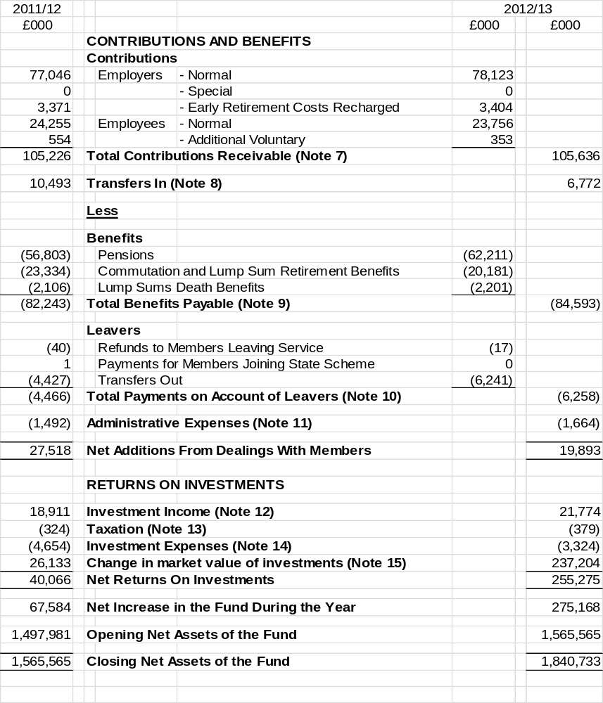

.

NORTH YORKSHIRE PENSION FUND - NET ASSETS STATEMENT

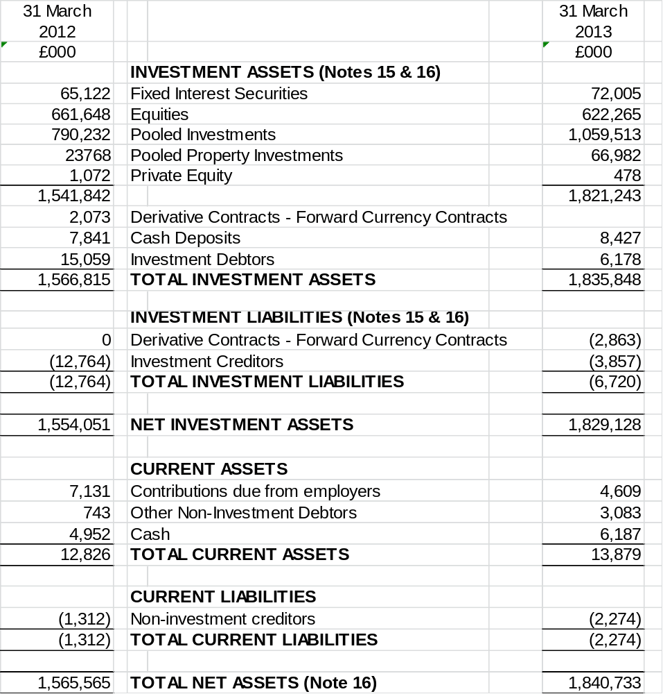

The accounts summarise the transactions of the Fund and deal with the net assets. They do not take account of the obligations to pay pensions and benefits which fall after the end of the Fund year.

NOTES TO THE NORTH YORKSHIRE PENSION FUND ACCOUNTS
FOR THE YEAR ENDED 31 MARCH 2013

1. Description of the Fund

The North Yorkshire Pension Fund (NYPF) is part of the Local Government Pension Scheme (LGPS) and is administered by North Yorkshire County Council (NYCC). The County Council is the reporting entity for the Fund.

The following description of the Fund is a summary only. For more detail, refer to the NYPF Annual Report 2012/13 and the statutory powers underpinning the scheme, namely the Superannuation Act 1972 and the Local Government Pension Scheme (LGPS) Regulations.

a) General

The Fund is governed by the Superannuation Act 1972 and is administered in accordance with the following legislation:

- the LGPS (Benefits, Membership and Contributions) Regulations 2007 (as amended)
- the LGPS (Administration) Regulations 2008 (as amended)
- the LGPS (Management and Investment of Funds) Regulations 2009

It is a defined benefit pension scheme administered by NYCC to provide pensions and other benefits for pensionable employees of NYCC, other local authorities in North Yorkshire and a range of other scheduled and admitted bodies within the county. Teachers, police officers and fire fighters are included within other national pension schemes.

The Fund is overseen by the Pension Fund Committee, which is a committee of NYCC.

b) Membership

Membership of the LGPS is voluntary and employees are free to choose whether to join the Scheme, remain in the Scheme or make their own personal arrangements outside the Scheme.

Organisations participating in NYPF include:

- scheduled bodies, which are local authorities and similar bodies whose staff are automatically entitled to be members of the Fund
- admitted bodies, which are other organisations that participate in the fund under an admission agreement between the Fund and the relevant organisation. Admitted bodies include voluntary, charitable and similar bodies or private contractors undertaking a local authority function following outsourcing to the private sector

At 31 March 2013 there were 86 contributing employer organisations within NYPF including the County Council itself, as detailed below:

55 Scheduled Bodies:
North Yorkshire County Council Norton on Derwent Town Council
City of York Council Knaresborough Town Council
Craven District Council Glusburn Parish Council
Hambleton District Council Skipton Town Council
Harrogate Borough Council Richmond Town Council
Richmondshire District Council Northallerton and Romanby Joint Burial Ctte
Ryedale District Council Northallerton Town Council
Scarborough Borough Council Malton Town Council
Selby District Council Pickering Town Council
North Yorkshire PCC Hunmanby Parish Council
North Yorkshire Police Force Great Ayton Parish Council
North Yorkshire Fire and Rescue Authority Haxby Town Council
York and North Yorkshire Probation Trust Ripon City Council
Yorkshire Dales National Park Easingwold Town Council
North York Moors National Park Kirkbymoorside Parish Council
Foss 2008 Internal Drainage Board Filey Town Council
Ainsty 2008 Internal Drainage Board York College
Thornton Internal Drainage Board Askham Bryan College
Whitby Town Council Selby College
Fulford Parish Council Craven College
Sutton-in-Craven Parish Council Scarborough Sixth Form College
Selby Town Council Harrogate Grammar School
Riccall Parish Council South Craven School
Archbishop Holgate St Aidens High School
Manor CE School Great Smeaton Primary School
Ripon College Norton College
Harrogate High School Rossett School
Skipton Girls High School

31 Admitted Bodies:
University of Hull, Scarborough Campus York St John University
York Archaeological Trust Yorkshire Housing
Joseph Rowntree Charitable Trust Welcome to Yorkshire
Community Leisure Ltd North Yorks Business Enterprise Partnership
Ringway York Museum and Galleries Trust
Yorkshire Coast Homes Craven Housing
Jacobs Engineering UK Richmondshire Leisure Trust
Superclean Services Enterprise
Interserve Human Support Group
Veritau Limited Scarborough Museums Trust
Veritau NY Sheffield International Venues
Wigan Leisure and Culture Trust
North Yorkshire LMS Pool York LMS Pool
- Mellors Catering Services - Chartwells compass
- Grosvenor Facilities Management - Future Cleaning
- Elite - ISS Mediclean Ltd
- Derwent Facilities - Springfield Homecare

Active, pensioner and deferred pensioner numbers, split between NYCC as the Administering Authority and all other employers was as follows:

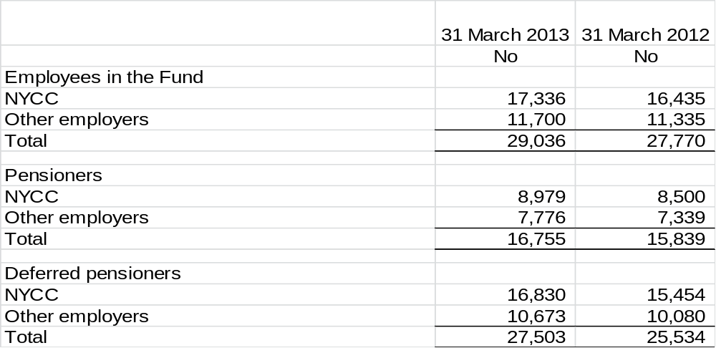

c) Funding

Benefits are funded by contributions and investment earnings. Contributions are made by active members of the Fund in accordance with the LGPS (Benefits, Membership and Contributions) Regulations 2007 (as amended) and range from 5.5% to 7.5% of pensionable pay for the financial year ended 31 March 2013. Employee contributions are matched by employers’ contributions which are set based on triennial actuarial funding valuations. The last such valuation was at 31 March 2010 and details of the rates for individual employers are available on the Fund’s website.

d) Benefits

Pension benefits under the LGPS are based on final pensionable pay and length of pensionable service. For service up to 31 March 2008 each year worked is worth 1/80th of final pensionable salary, an automatic lump sum of three times salary is payable, and part of the annual pension can be exchanged for a one-off tax free cash payment at the rate of £12 lump sum for each £1 pension given up. For service from 1 April 2008 each year worked is worth 1/60th of final pensionable salary, there is no automatic lump sum, and part of the annual pension can be exchanged at the same rate as for service up to 31 March 2008.

There are a range of other benefits provided under the Scheme including early retirement, disability pensions and death benefits. For more details please refer to the Publications section of the Fund’s website.

Benefits are index linked in order to keep pace with inflation. In June 2010 the Government announced that the method of indexation would change from the retail price index to the consumer price index. This change took effect from 1 April 2011.

LGPS 2014

It is expected that new regulations setting out details of LGPS 2014 will be laid before the end of March 2014. Further details, including planned key benefit changes can be found at www.lgps.org.uk.

- Basis of Preparation

The Statement of Accounts summarises the Fund’s transactions for the 2012/13 financial year and its year end position as at 31 March 2013. The accounts have been prepared in accordance with the Code of Practice on Local Authority Accounting in the United Kingdom 2012/13 which is based upon International Financial Reporting Standards (IFRS), as amended for the UK public sector.

The accounts summarise the transactions of the Fund and report on the net assets available to pay pension benefits. The Accounts do not take account of obligations to pay pensions and benefits which fall due after the end of the financial year. The actuarial present value of promised retirement benefits, valued on an International Accounting Standard (IAS) 19 basis, is disclosed at Note 19 of these accounts.

- Summary of Significant Accounting Policies

Fund Account – Revenue Recognition

a) Contribution Income

Normal contributions, both from the members and from the employer, are accounted for on an accruals basis at the rate recommended by the Fund’s Actuary in the payroll period to which they relate.

Employers’ augmentation contributions and pension strain contributions are accounted for in the period in which the liability arises. Any amount due in year but unpaid will be classed as a current asset.

b) Transfers To and From Other Schemes

Transfer values represent the amounts received and paid during the year for members who have either joined or left the Fund during the financial year and are calculated in accordance with LGPS Regulations.

Individual Transfers in/out are accounted for when received/paid, which is normally when the member liability is accepted or discharged.

Transfers in from members wishing to use the proceeds of their additional voluntary contributions or other defined contribution arrangements to purchase scheme benefits are accounted for on a receipts basis.

Bulk (group) transfers are accounted for on an accruals basis in accordance with the terms of the transfer agreement.

c) Investment Income

Interest income is recognised in the Fund as it accrues, using the effective interest rate of the financial instrument as at the date of acquisition or origination. Income includes the amortisation of any discount or premium, transaction costs or other differences between the initial cost of the instrument and its value at maturity calculated on an effective interest rate basis.

Dividend income is recognised on the date the shares are quoted ex-dividend. Any amount not received by the end of the reporting period is disclosed in the Net Assets Statement as a current asset.

Distributions from pooled funds are recognised at the date of issue. Any amount not received by the end of the reporting period is disclosed in the Net Asset Statement as a current asset.

Changes in the net market value of investments are recognised as income and comprise all realised and unrealised profits/losses during the year.

Fund Account – Expense Items

d) Benefits Payable

Pensions and lump sum benefits payable include all amounts known to be due as at the financial year end. Any amounts due but unpaid are disclosed in the Net Assets Statement as current liabilities.

e) Taxation

The Fund is a registered public service scheme under Section 1(1) of Schedule 36 of the Finance Act 2004 and as such is exempt from UK income tax on interest received and from capital gains tax on the proceeds of investments sold. Income from overseas investments suffers withholding tax in the country of origin, unless exemption is permitted. Irrecoverable tax is accounted for as a Fund expense as it arises.

f) Administrative Expenses

All administrative expenses are accounted for on an accruals basis. All staff costs of the Pensions Administration Team are charged to the Fund. Management, accommodation and other overheads are apportioned to the Fund in accordance with NYCC policy.

g) Investment Management Expenses

All investment management expenses are accounted for on an accruals basis.

Fees of the external investment managers are set out in the respective mandates governing their appointments. Broadly, these are based on the market value of the investments under their management and therefore increase or reduce as the value of these investments change.

In addition the Fund has negotiated with the following managers that an element of their fee will be performance related:

- Baillie Gifford & Co - Global Equities
- FIL Pensions Management (Fidelity) - Global (ex-UK) Equities
- Standard Life Investments – UK Equities

Performance related fees were £217k in 2012/13 (£1,167k in 2011/12).

Where an investment manager’s fee note has not been received by the balance sheet date, an estimate based upon the market value of their mandate as at the end of the year is used for inclusion in the Fund Account. In 2012/13 £300k of fees is based on such estimates (£399k in 2011/12).

Net Assets Statement

h) Assets

Assets are included in the Net Asset Statement on a fair value basis as at the reporting date. An asset is recognised in the Net Asset Statement on the date the Fund becomes party to the contractual acquisition of the asset. From this date any gains or losses arising from the fair value of the asset are recognised by the Fund.

The values of investments as shown in the Net Assets Statement have been determined as follows:

- the value of investments for which there are readily available market prices are determined by the bid market prices
- fixed interest securities are recorded at net market value based on prevailing yields
- interests in limited partnerships are based on the net asset value ascertained from periodic valuations provided by those controlling the partnership
- pooled investment vehicles are valued at closing bid price if both bid and offer prices are published, otherwise at the closing single price. In the case of pooled investment vehicles that are accumulation funds, the change in market value also includes income which is reinvested in the Fund, net of applicable withholding tax

i) Foreign Currency Transactions

Dividends, interest and purchases and sales of investments in foreign currencies have been accounted for at the spot market rates at the date of transaction. End of year spot market exchange rates are used to value cash balances held in foreign currency bank accounts, market values of overseas investment and purchases and sales outstanding at the end of the reporting period.

j) Derivatives

The Fund uses derivative financial instruments to manage its exposure to specific risks arising from its investment activities. The Fund does not hold derivatives for speculative purposes.

The value of forward currency contracts is based on market forward exchange rates at the year end and determined as the gain or loss that would arise if the outstanding contract were matched at the year end with an equal and opposite contract.

k) Cash and Cash Equivalents

Cash comprises cash in hand and demand deposits.

Cash equivalents are short term, highly liquid investments that are readily convertible into known amounts of cash and that are subject to minimal risk of change in value.

l) Liabilities

The Fund recognises liabilities at fair value as at the reporting date. A liability is recognised in the Net Asset Statement on the date the Fund becomes party to the liability. From this date any gains or losses arising from changes in the fair value of the liability are recognised by the Fund.

m) Actuarial Present Value of Promised Retirement Benefits

The actuarial present value of promised retirement benefits is assessed on a triennial basis by the Fund’s Actuary in accordance with the requirements of IAS19 and relevant actuarial standards.
As permitted under IAS26, the Fund has opted to disclose the actuarial present value of promised retirement benefits by way of an Appendix to these statements.

n) Additional Voluntary Contributions

NYPF provides an Additional voluntary contribution (AVC) scheme for its members, the assets of which are invested separately from those of the Fund. The fund has appointed Prudential as its AVC provider. AVCs are paid to the AVC provider by employers and are specifically for providing additional benefits for individual contributors. Each AVC contributor receives an annual statement showing the amount held in their account and the movements in the year.

AVCs are not included in the Accounts in accordance with Section 4(2)(b) of the LGPS (Management and Investment of Funds) Regulations 2009 (SI 2009/3093) but are disclosed as a note only (Note 22).

4. Critical Judgement in Applying Accounting Policies

Unquoted Private Equity Investments

It is important to recognise the highly subjective nature of determining the fair value of private equity investments. They are inherently based on forward looking estimates and judgements involving many factors. Unquoted private equities are valued by the investment manager using guidelines set out by the British Venture Capital Association. The value of unquoted private equities at 31 March 2013 was £478k (31 March 2012, £1,072k).

Pension Fund Liability

The Fund’s liability is calculated every three years by the Actuary, with annual updates in the intervening years. The methodology used is in line with accepted guidelines and in accordance with IAS19. Assumptions underpinning the valuations are agreed with the Actuary and are summarised in Note 18. This estimate is subject to significant variances based on changes to the underlying assumptions.

- Assumptions Made About the Future and Other Major Sources of Estimation Uncertainty

These Accounts contain estimated figures that are based on assumptions made by the Fund about the future or that are otherwise uncertain. Estimates are made taking into account historical experience, current trends and other relevant factors. However, as these figures cannot be determined with certainty, actual results could be materially different using different assumptions.

The item in the Net Assets Statement as at 31 March 2013 for which there is a significant risk of material adjustment being required is the actuarial present value of promised retirement benefits, which is based on assumptions on the discount rate, salary increases, retirement ages, mortality rates and the return on investments.

The effects of changing individual assumptions on the value of pension liabilities can be measured. A 0.1% increase in the discount rate would reduce liabilities by £54m, a 0.1% increase in inflation would increase liabilities by £56m, and an increase in life expectancy of one year would increase liabilities by £62m.

- Events After the Balance Sheet Date

Since 31 March 2013 there have been significant movements in global financial markets which would impact upon the market value of the Fund’s investments were they to be valued as at the date these Accounts were authorised. This change is deemed to be a non-adjusting post balance sheet event.

There have been no events since 31 March 2013, and up to the date when these accounts were authorised that require any adjustments to these Accounts.

7. Contributions Receivable

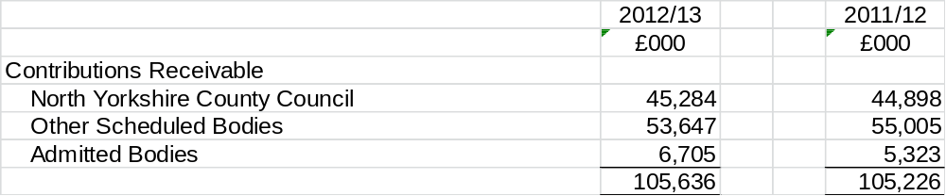

The analysis of contributions for 2011/12 has been amended to reflect changes in the status of some employer organisations.

8. Transfers In from Other Pension Funds

All Transfers In were individual transfers. There were no group transfers during the year.

9. Benefits Payable

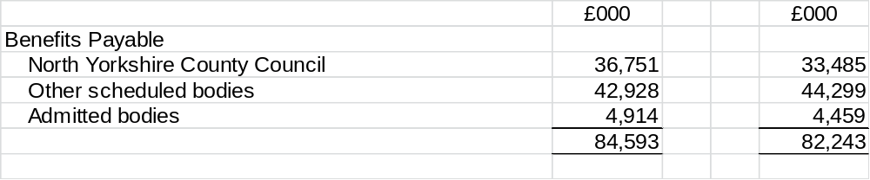

The analysis of benefits for 2011/12 has been amended to reflect changes in the status of some employer organisations.

- Payments To and On Account of Leavers

All Transfers Out were individual transfers. There were no group transfers during the year.

- Administrative Expenses

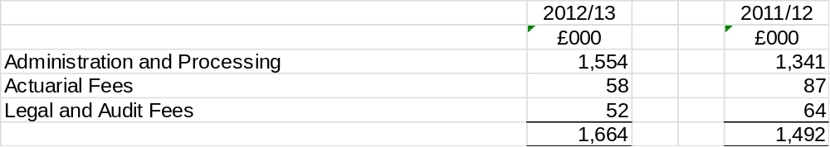

- Investment Income

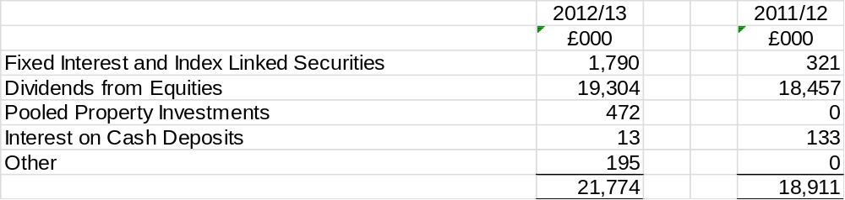

- Taxes on Income

- Investment Expenses

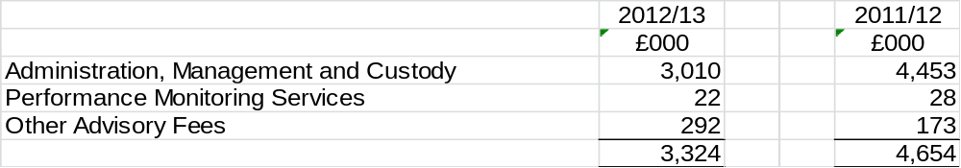

- Investments

a) Reconciliation of Movements in Investments and Derivatives
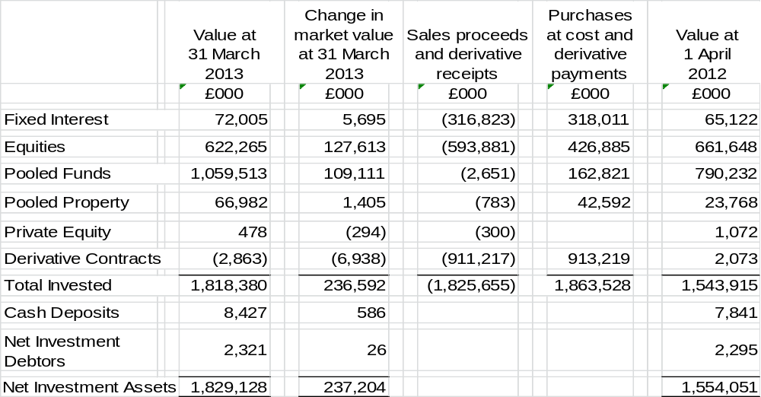

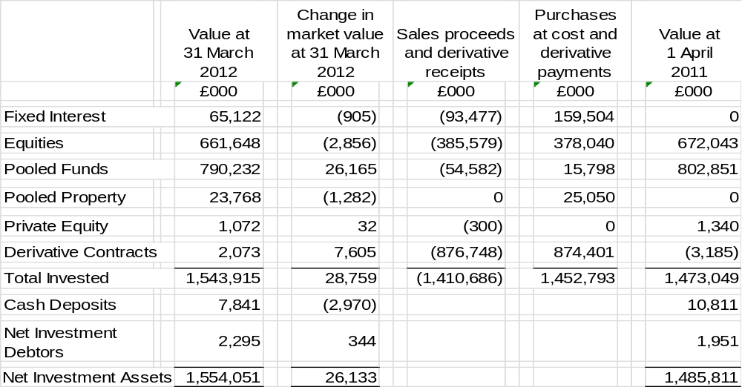

Transaction costs are included in the cost of purchases and sale proceeds. These include costs charged directly to the Fund, such as fees, commissions and stamp duty. Transaction costs incurred during the year amounted to £959k (2011/12 £885k). In addition indirect costs are incurred through the bid–offer spread on investments within pooled investment vehicles. These investment vehicles are managed by Investment Managers registered in the UK. The amount of indirect costs is not separately provided to the Pension Fund.

b) Analysis of Investments (excluding derivative contracts)

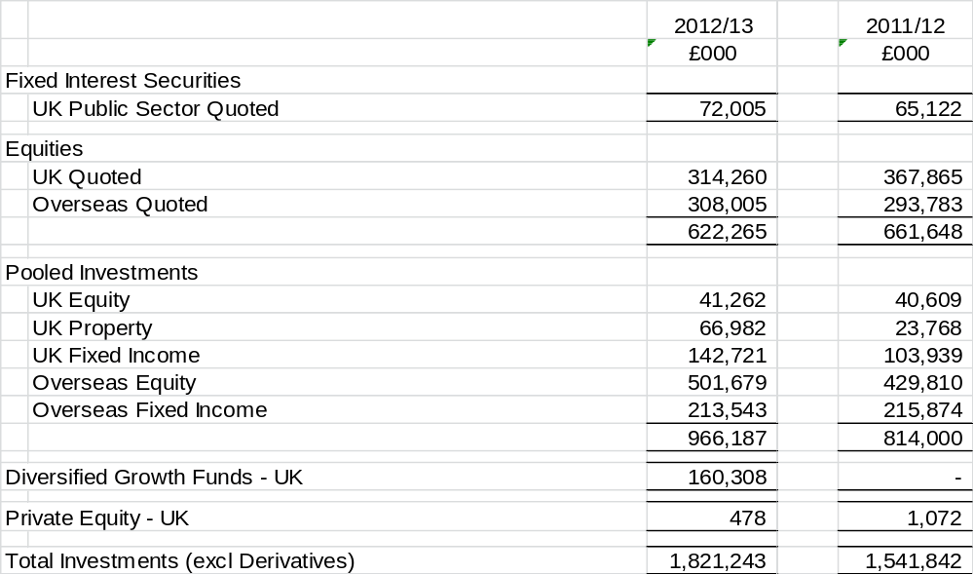

Analysis of Derivatives

Objectives and Policies for Holding Forward Foreign Currency Derivatives

In order to maintain appropriate diversification and to take advantage of overseas investment returns, a significant proportion of the Fund’s quoted equity portfolio is in overseas stock markets. To reduce the volatility associated with fluctuating currency rates, the Fund has a passive currency programme in place managed by NYCC. The Fund hedges a proportion (25%) of the US Dollar, Euro, Japanese Yen, Swiss Franc and Swedish Krona exposure.

Open Forward Currency Contracts

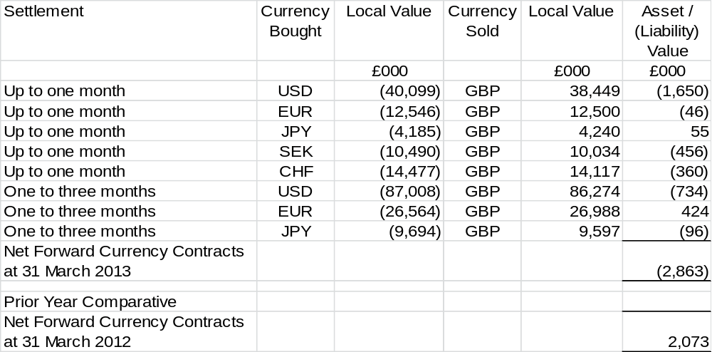

Investments Analysed by Fund Manager

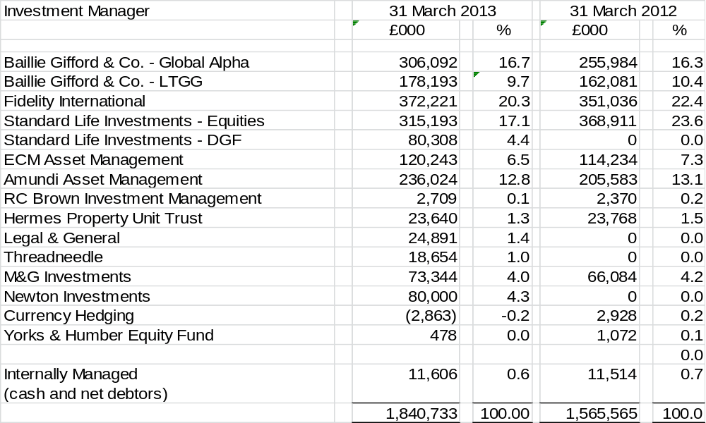

The investments with Baillie Gifford, European Credit Management and Amundi each represent more than 5% of net assets. These investments are in pooled funds. All other investments are either below 5% or constitute a portfolio of segregated assets.

c) Stock Lending

The Fund has not released stock to a third party under a stock lending arrangement within a regulated market at this period end or in any previous years.

- Financial Instruments

a) Classification of Financial Instruments

Accounting policies describe how different asset classes of financial instruments are measured, and how income and expenses, including fair value gains and losses, are recognised. The following table summarises the carrying amounts of financial assets and liabilities by category.

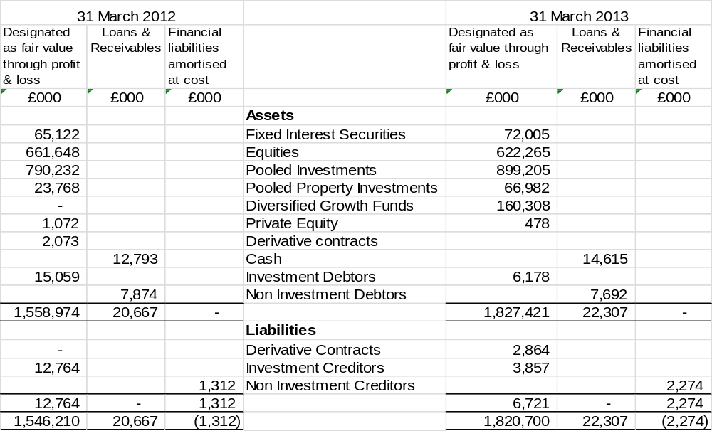

- Net Gains and Losses on Financial Instruments

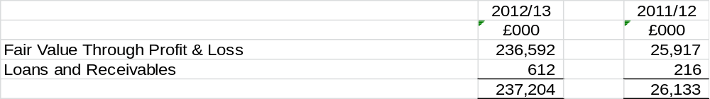

- Fair Value of Financial Instruments and Liabilities

The following table summarises the cost of the assets and liabilities by class of instrument compared with their fair values in the Accounts.

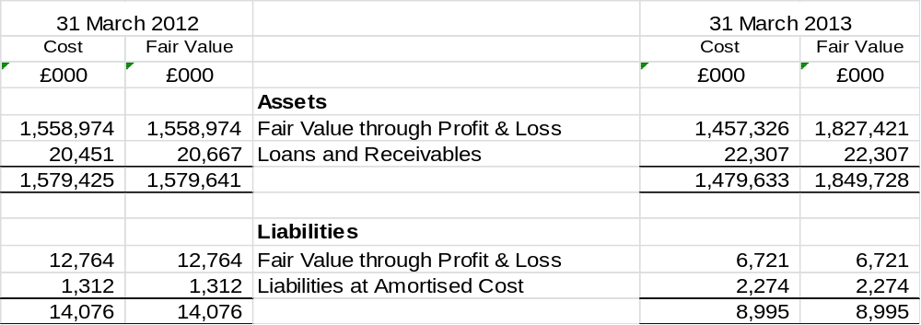

NYCC has not entered into any financial guarantees that are required to be accounted for as financial instruments.

- Valuation of Financial Instruments Carried at Fair Value

The valuation of financial instruments has been classified into three levels, according to the quality and reliability of information used to determine fair values.

Level 1

Financial instruments at Level 1 are those where the fair values are derived from unadjusted quoted prices in active markets for identical assets and liabilities. Products classified as Level 1 comprise quoted equities, quoted fixed securities, quoted index linked securities and unit trusts.

Listed investments are shown at bid prices. The bid value of the investment is based on the bid market quotation of the relevant stock exchange.

Level 2

Financial instruments at Level 2 are those where quoted market prices are not available, for example where an instrument is traded in a market that is not considered to be active or where valuation techniques are used to determine fair value and where these techniques use inputs that are based significantly on observable market data.

Level 3

Financial instruments at Level 3 are those where at least one input that could have a significant effect in the instrument’s valuation is not based on observable market data. Such instruments would include unquoted equity investments, which are valued using various valuation techniques that require significant judgement in determining appropriate assumptions.

The value of the investment in private equity is based on a valuation provided by the manager of the fund in which NYPF has invested. This valuation has been prepared in accordance with the British Venture Capital Association guidelines. Formal valuations are undertaken annually as at the end of December.

The following table provides an analysis of the assets and liabilities of the Fund grouped into Levels 1 to 3, based on the level at which the fair value is observable.

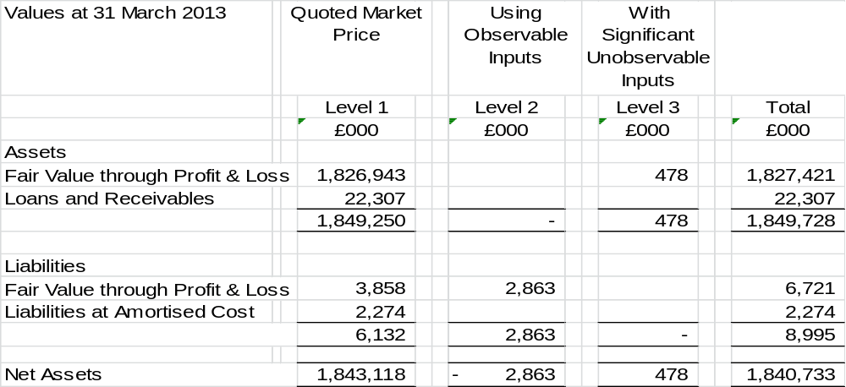

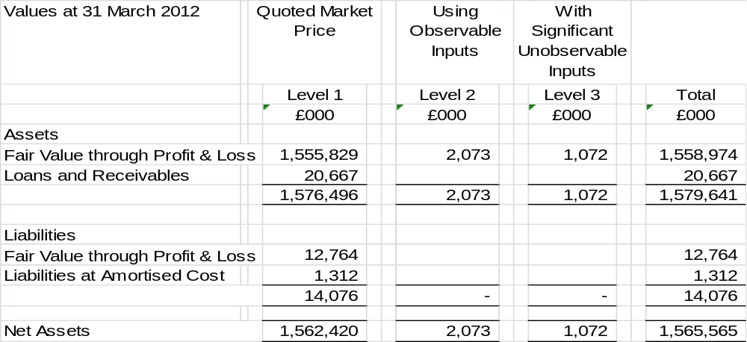

17. Nature and Extent of Risks Arising from Financial Instruments

Risk and Risk Management

The Fund’s primary long term risk is that the Fund’s assets will fall short of its liabilities (i.e. promised benefits payable to members). Therefore the aim of investment risk management is to minimise the risk of an overall reduction in the value of the Fund and to maximise the opportunity for gains across the whole Fund portfolio. The Fund achieves this through asset diversification to reduce exposure to market risk (price risk, currency risk and interest rate risk) and credit risk to an acceptable level. In addition, the fund manages its liquidity risk to ensure there is sufficient liquidity to meet the Fund’s forecast cash flows. NYCC manages these investment risks as part of its overall approach to Pension Fund risk.

Responsibility for the Fund’s risk management strategy rests with the Pension Fund Committee. A Risk Register has been established to identify and analyse the risks faced by NYCC’s pensions operations. This document is periodically reviewed regularly to reflect changes in activity and in market conditions.

- Market Risk

Market risk is the risk of loss from fluctuations in equity prices, interest and foreign exchange rates and credit spreads. The Fund is exposed to market risk from its investment activities, particularly through its equity holdings. The level of risk exposure depends on market conditions, expectations of future price and yield movements and the asset mix.

The objective of the Fund’s Risk Register includes identifying, managing and controlling market risk exposure within acceptable parameters, whilst optimising the return on risk.

In general, excessive volatility in market risk is managed through the diversification of the portfolio in terms of geographical and industry sectors and individual securities. To mitigate market risk, the PFC and its investment advisers undertake appropriate monitoring of market conditions and benchmark analysis.

The Fund manages these risks in two ways:

- the exposure of the Fund to market risk is monitored through advice from the investment advisers to ensure that risk remains within tolerable levels

- specific risk exposure is limited by applying risk weighted maximum exposures to individual investments through Investment Management Agreements

Other Price Risk

Other price risk represents the risk that the value of a financial instrument will fluctuate as a result of changes in market prices (other than those arising from interest rate risk or foreign exchange risk), whether those changes are caused by factors specific to the individual instrument or its issuer or factors affecting all such instruments in the market.

The Fund is exposed to share and derivative price risk. This arises from investments held by the Fund for which the future price is uncertain. All securities investments present a risk of loss of capital. The maximum risk resulting from financial instruments is determined by the fair value of the financial instruments.

The Fund’s investment managers mitigate this price risk through diversification and the selection of securities and other financial instruments is monitored to ensure it is within limits specified in the Fund’s investment strategy.

Following analysis of historical data and expected investment return movement during the financial year, the following table shows movements in market price risk that are reasonably possible for the 2013/14 reporting period, assuming other variables such as foreign currency rates and interest rates remain unchanged. The changes disclosed are broadly consistent with a one standard deviation movement in the value of assets. A prior year comparator is also shown below.

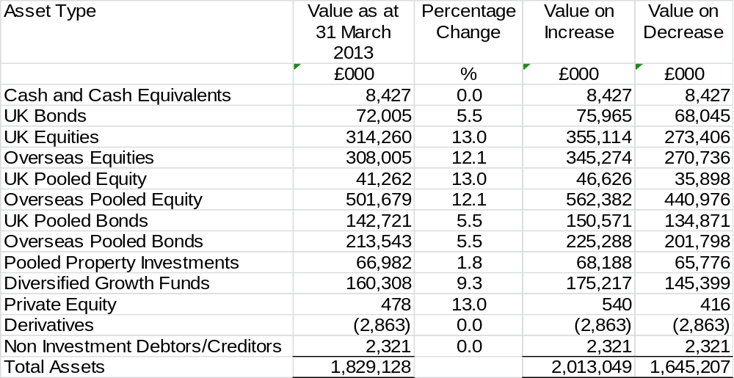

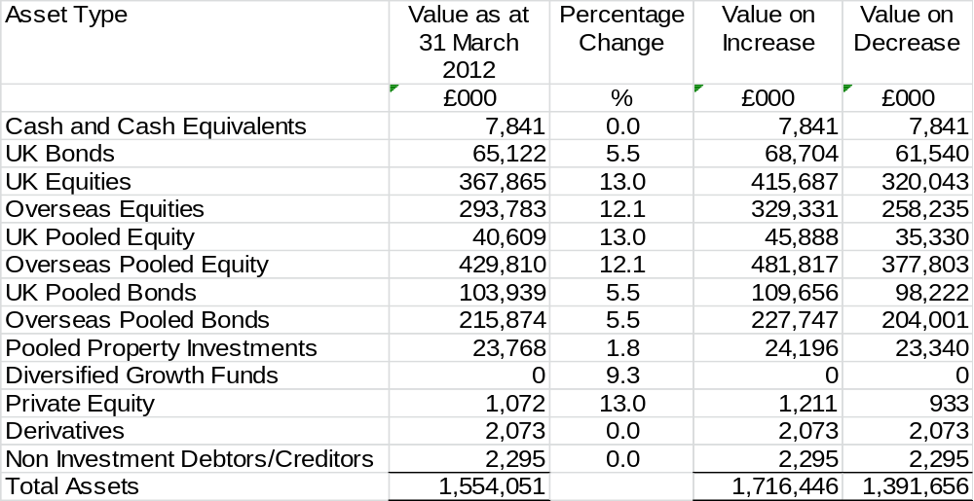

Interest Rate Risk

The Fund invests in financial assets for the primary purpose of obtaining a return on investments. These investments are subject to interest rate risks, which represent the risk that the fair value or future cash flows of a financial instrument will fluctuate because of changes in market interest rates.

The Fund’s interest rate risk is monitored by the Fund and its investment advisers through the risk management strategy including monitoring the exposure to interest rates and assessment of actual interest rates against the strategic benchmark.

The Fund’s direct exposure to interest rate movements as at 31 March 2013 and 31 March 2012 is set out in the tables below. These disclosures present interest rate risk based on the underlying financial assets at fair value.

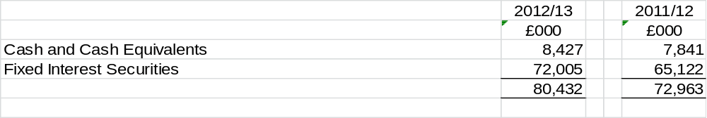

The Fund recognises that interest rates can vary and can affect both income to the Fund and the value of the net assets available to pay benefits. No figures are available for a predicted movement in the long term average rate. However for illustrative purposes if it were to change by +/- 25 bps the values in the table above would change by £201k and for 2011/12 asset values, £182k.

Currency Risk

Currency risk represents the risk that the fair value of future cash flows of a financial instrument will fluctuate because of changes in foreign exchange rates. The Fund is exposed to currency risk on financial instruments that are denominated in any currency other than the functional currency of the Fund (£UK). The Fund holds both monetary and non monetary assets denominated in currencies other than £UK.

The Fund’s currency rate risk is monitored in accordance with the Fund’s risk management strategy, including monitoring the range of exposure to currency fluctuations.

After receiving advice it is considered that the likely volatility associated with foreign exchange movements to be +/-5.5%. A fluctuation of this size is considered reasonable based on the analysis of long term historical movements in the month end exchange rates.

Assuming all other variables, in particular, interest rates remain constant, a 5.5% strengthening/weakening of the pound against the various currencies in which the Fund holds investments would increase/decrease the net assets available to bay benefits as follows:

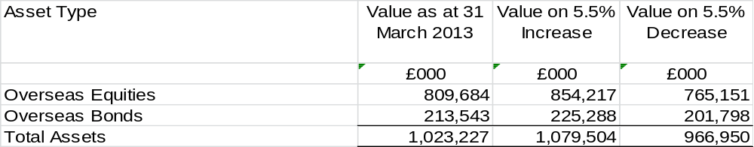

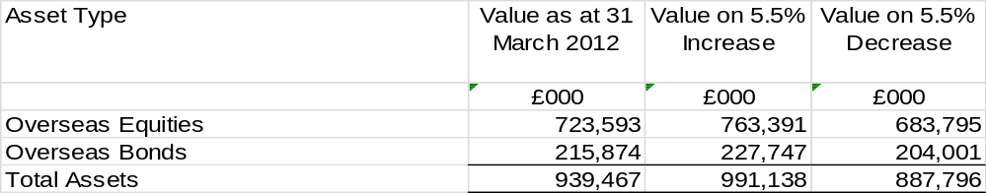

- Credit Risk

Credit risk represents the risk that the counterparty to a transaction or a financial instrument will fail to discharge an obligation and cause the Fund to incur a financial loss. The market values of investments generally reflect an assessment of credit in their pricing and consequently the risk of loss is implicitly provided for in the carrying value of the Fund’s assets and liabilities.

In essence the Fund’s entire investment portfolio is exposed to some form of credit risk, with the exception of the derivative positions, where the risk equates to the net market value of a positive derivative position. However the selection of high quality counterparties, brokers and financial institutions minimises credit risk that may occur through the failure to settle a transaction in a timely manner.

Contractual credit risk is represented by the net payment or receipt that remains outstanding, and the cost of replacing the derivative position in the event of counterparty default. The residual risk is minimal due to the various insurance policies held by the exchanges to cover defaulting counterparties.

Credit risk on over the counter derivative contracts is minimised as counterparties are recognised financial intermediaries with acceptable credit ratings determined by recognised rating agencies.

Deposits are not made with banks and financial institutions unless they are rated independently and meet NYCC’s credit criteria. NYCC has also set limits as to the maximum amount of deposits placed with any one financial institution. Money market funds chosen all have at least the minimum credit rating as described in NYCC’s Treasury Management Strategy.

NYCC believes it has managed its exposure to credit risk and has had no experience of default or uncollectible deposits over the past five financial years. The Fund’s cash holding under its treasury management arrangements with NYCC at 31 March 2013 was £6.2m (31 March 2012, £5.1m) and was held with the following institutions:

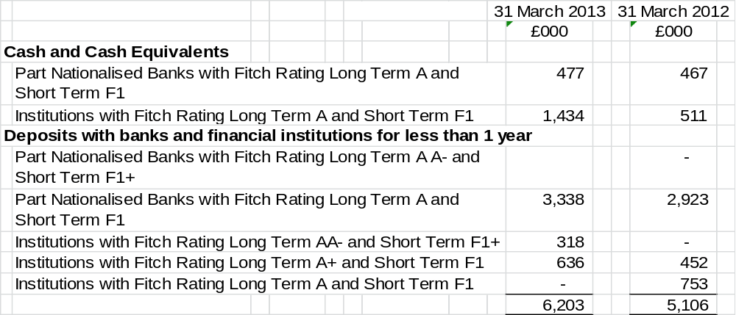

c) Liquidity Risk

Liquidity risk represents the risk that the fund will not be able to meet its financial obligations as they fall due. The Fund therefore takes steps to ensure that it has adequate cash resources to meet its commitments.

The Fund has immediate access to its cash holdings, subject to the fixed periods determined when deposits are placed. These deposits are scheduled to ensure cash is available when required.

The Fund also has access to an overdraft facility for short term (up to three months) cash needs. This facility is only used to address changes in the strategic benchmark and is met by either surplus cash from contributions received exceeding pensions paid or if necessary, disinvesting.

The fund defines liquid assets as assets that can be converted to cash within three months. Illiquid assets are those assets which will take longer than three months to convert to cash. As at 31 March 2013 the value of illiquid assets was £478k, which represented less than 0.1% of total Fund assets (31 March 2012, £1,072k, which represented less than 0.1% of total Fund assets).

All liabilities at 31 March 2013 are due within one year.

The Fund does not have any financial instruments that have a refinancing risk as part of its treasury management and investment strategies.

18. Funding Arrangements

In line with the Local Government Pension Scheme (Administration) Regulations 2008 the Fund’s Actuary, Mercer, undertakes a funding Valuation every three years for the purpose of setting employer contribution rates for the forthcoming triennial period. The last such Valuation took place as at 31 March 2010 and set employer contribution rates for the three years from 2011/12. The next Valuation will take place as at 31 March 2013, is currently underway, and will set employer contribution rates for the three years from 2014/15.

The key elements of NYPF’s funding policy are:

- to ensure the long term solvency of the Fund, i.e. that sufficient funds are available to meet all pension liabilities as the fall due for payment
- to ensure that employer contribution rates are as stable as possible
- to minimise the long term cost of the scheme by recognising the link between assets and liabilities and adopting an investment strategy that balances risk and return
- to reflect the different characteristics of employing bodies in determining contribution rates where the Administering Authority considers it reasonable to do so
- to use reasonable measures to reduce the risk to other employers and ultimately to the council tax payer from an employer defaulting on its pension obligations

The Common Rate of employers’ contributions is the average rate required from all employers calculated as being sufficient, together with contributions paid by employees, to meet all liabilities arising in respect of service after the Valuation date. For the three years 2011/12 to 2013/14 the Common Rate is 12.2% of pensionable pay.

The Common Rate was adjusted to establish a Future Service Rate (FSR) for each employer, having regard to their individual circumstances, particularly to reflect the numbers of starters/leavers/early retirements since the last Valuation date.

At the 2010 Triennial Valuation the Fund was assessed as 67% funded (67% at the 2007 Valuation). This reflected a deficit of £659m (£619m at the 2007 Valuation). In order to address this deficit whilst managing the costs of the Scheme to the taxpayer, the Fund continued to follow Communities and Local Government guidance and stabilise contribution rates by adopting a deficit recovery period of 30 years from 1 April 2011. Therefore, an average additional contribution rate of 6.4% (over 30 years) was required to fund the deficit, implying an average employer contribution rate of 18.6% (12.2% + 6.4%) of pensionable pay, compared to 18.8% at the 2007 Valuation.

An additional Deficit Contribution Rate (DCR) was established for each employer depending upon their individual circumstances, particularly to reflect the solvency position at the last Valuation.

Any increases in either the FSR or DCR arising from the 2010 Triennial Valuation are phased over a period of up to three years. Full details of the contribution rates payable by each employer can be found in the 2010 Valuation Report on the Fund’s website.

The valuation of the Fund has been undertaken using the projected unit method under which the salary increase for each member is assumed to increase until they leave active service by death, retirement or withdrawal from service. The principal assumptions were:

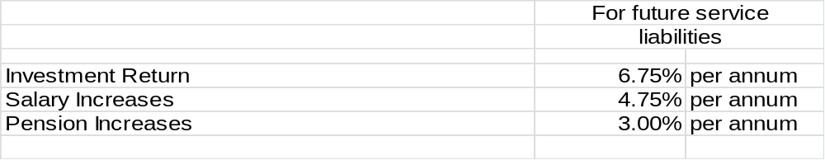

Future life expectancy based on the Actuary’s Fund specific mortality review was:

Life expectancy for the year to 31 March 2013 is based on SPA02 and CMI2009 actuarial tables and includes an allowance for a minimum improvement each year of 1%.

It is assumed that future retirees will take 50% of the maximum additional tax-free lump sum up to HMRC limits for pre-April 2008 and for post-April 2008 service.

19. Actuarial Present Value of Promised Retirement Benefits

In addition to the Triennial Funding Valuation, the Actuary also undertakes a valuation of pension fund liabilities on an IAS19 basis every year using the same base data as the Valuation, rolled forward to the current financial year, taking account of changes in membership numbers and using updated assumptions. A statement prepared by the Actuary is attached as an Appendix.

- Current Assets

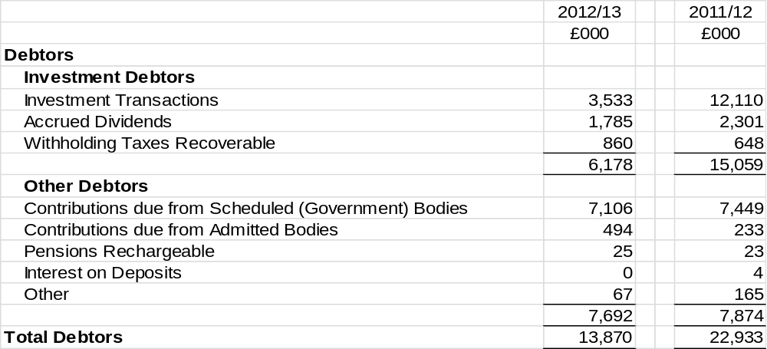

- Current Liabilities

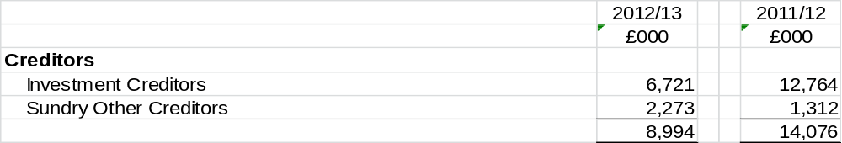

All creditors are non government entities and individuals.

22. Additional Voluntary Contributions (AVCs)

Members may make Additional Voluntary Contributions (AVCs) which are invested in insurance policies with the Prudential Assurance Company Limited on behalf of the individual members concerned.

The AVCs are not included in the Pension Fund Accounts in accordance with regulation 5(2)(c) of the Local Government Pension Scheme (Management and Investment of Funds) Regulations 1998.

AVC contributions of £2,226k were paid directly to Prudential during the year (£2,352k in 2011/12). The total value of the AVC Fund serviced by these contributions as at 31 March was:

- Related Party Transactions

North Yorkshire County Council

The North Yorkshire Pension Fund is administered by North Yorkshire County Council. Consequently there is a strong relationship between the Council and the Fund.

The Council incurred costs of £1,064k (£1,103k in 2011/12) in relation to the administration of the Fund and was subsequently reimbursed by the Fund for these expenses. The Council is also the single largest employer of members of the Fund and contributed £45.3m to the Fund in 2012/13 (£44.9m in 2011/12). All monies owing to and due from the Fund were paid in the year.

Part of the Fund’s cash holdings are invested on the money markets by the treasury management operations of the Council, through a service level agreement. During the year to 31 March 2013 the Fund had an average investment balance of £(2.2m) (£5.2m during 2011/12) paying interest of £26k (£65k earned in 2011/12) in these funds.

Governance

As at 31 March 2013 there were five Pension Fund Committee Members who were also active members of the Fund, each of whom was required to declare their interests at each meeting. The Corporate Director – Strategic Resources, who was also the Treasurer of the Fund was also an active member. Benefits for PFC Members and the Treasurer were accrued on exactly the same basis as for all other members of the Fund.

24. Contingent Liabilities and Contractual Commitments

The Fund had no material contingent liabilities or contractual commitments at the year end (£nil in 2011/12).

- Contingent Assets

Five admitted body employers hold insurance bonds to guard against the possibility of being unable to meet their pension obligations. These bonds are drawn in favour of the pension fund and payment will only be triggered in the event of an employer default.

- Impairment Losses

The Fund had no material impairment losses at the year end (£nil in 2011/12).


north yorkshire Pension Fund

Accounts for the year ended 31 March 2013 - Statement by the Consulting Actuary

This statement has been provided to meet the requirements under Regulation 34(1)(d) of The Local Government Pension Scheme (Administration) Regulations 2008.

An actuarial valuation of the North Yorkshire Pension Fund was carried out as at 31 March 2010 to determine the contribution rates with effect from 1 April 2011 to 31 March 2014.

On the basis of the assumptions adopted, the Fund’s assets of £1,345 million represented 67% of the Fund’s past service liabilities of £2,004 million (the “Funding Target”) at the valuation date.

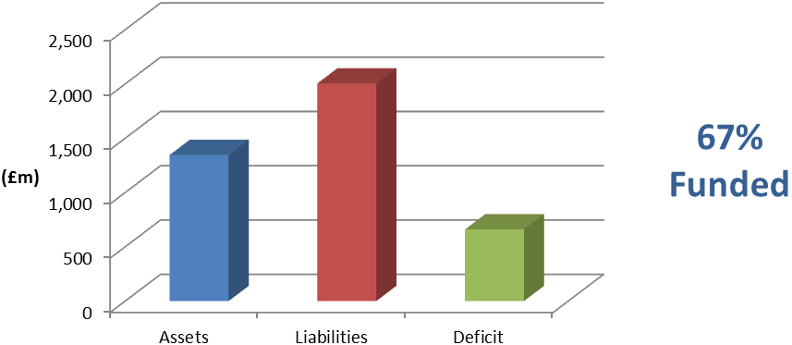
The valuation also showed that a common rate of contribution of 12.2% of pensionable pay per annum was required from employers. The common rate is calculated as being sufficient, together with contributions paid by members, to meet all liabilities arising in respect of service after the valuation date.
Adopting the same method and assumptions as used for assessing the Funding Target the deficit would be eliminated by an average additional contribution rate of 6.4% of pensionable pay for 30 years. This would imply an average employer contribution rate of 18.6% of pensionable pay in total.
Further details regarding the results of the valuation are contained in our formal report on the actuarial valuation dated 31 March 2011.

In practice, each individual employer’s position is assessed separately and the contributions required are set out in our report. In addition to the certified contribution rates, payments to cover additional liabilities arising from early retirements (other than ill-health retirements) will be made to the Fund by the employers.
The funding plan adopted in assessing the contributions for each individual employer is in accordance with the Funding Strategy Statement (FSS). Different approaches adopted in implementing contribution increases and deficit recovery periods are as determined through the FSS consultation process.
The valuation was carried out using the projected unit actuarial method and the main actuarial assumptions used for assessing the Funding Target and the common contribution rate were as follows:

 | For past service liabilities (Funding Target) | For future service liabilities (Common Contribution Rate)
Rate of return on investments (discount rate)  - pre retirement  - post retirement | 7.0% per annum  5.5% per annum | 6.75% per annum  6.75% per annum
Rate of pay increases | 4.75% per annum | 4.75% per annum
Rate of increases in pensions  in payment (in excess of  Guaranteed Minimum Pension) | 3.0% per annum | 3.0% per annum

The assets were assessed at market value.
The next triennial actuarial valuation of the Fund is due as at 31 March 2013. Based on the results of this valuation, the contribution rates payable by the individual employers will be revised with effect from 1 April 2014.

Actuarial Present Value of Promised Retirement Benefits for the Purposes of IAS 26

IAS 26 requires the present value of the Fund’s promised retirement benefits to be disclosed, and for this purpose the actuarial assumptions and methodology used should be based on IAS 19 rather than the assumptions and methodology used for funding purposes.

To assess the value of the benefits on this basis, we have used the following financial assumptions as at 31 March 2013 (the 31 March 2012 assumptions are included for comparison):

 | 31 March 2012 | 31 March 2013
Rate of return on investments (discount rate) | 4.9% per annum | 4.2% per annum
Rate of pay increases | 4.25% per annum | 4.15% per annum
Rate of increases in pensions  in payment (in excess of  Guaranteed Minimum Pension) | 2.5% per annum | 2.4% per annum

The demographic assumptions are the same as those used for funding purposes other than the allowance for future improvements in life expectancy, which has been updated taking into account the latest evidence on this issue. The updated allowance underlying the 31 March 2013 calculations is in line with the projections model published in November 2009 by the Continuous Mortality Investigation (CMI) with a long-term improvement rate of 1.25% p.a. The previous allowance as at 31 March 2012 used a long-term improvement rate of 1.0% p.a.

During the year, corporate bond yields reduced, resulting in a lower discount rate being used for IAS26 purposes at the year end than at the beginning of the year (4.2% p.a. versus 4.9% p.a.). The impact of this was offset slightly by the 0.1% p.a. fall in assumed inflation.

The value of the Fund’s promised retirement benefits for the purposes of IAS26 as at 31 March 2012 was estimated as £2,595 million. The effect of the changes in actuarial assumptions between 31 March 2012 and 31 March 2013 as described above is to increase the liabilities by c£340 million. Adding interest over the year increases the liabilities by a further c£127 million, and allowing for net benefits accrued/paid over the period increases the liabilities by another c£16 million. The net effect of all the above is that the estimated total value of the Fund’s promised retirement benefits as at 31 March 2013 is therefore £3,078 million.

Ian Kirk

Fellow of the Institute and Faculty of Actuaries

Mercer Limited
June 2013

APPENDIX B

INDEPENDENT AUDITOR’S REPORT TO THE MEMBERS OF NORTH YORKSHIRE COUNTY COUNCIL
Opinion on the pension fund accounting statements
We have audited the pension fund financial statements for the year ended 31 March 2013 under the Audit Commission Act 1998. The pension fund financial statements comprise the Fund Account, the Net Assets Statement and the related notes 1 to 26. The financial reporting framework that has been applied in their preparation is applicable law and the CIPFA/LASAAC Code of Practice on Local Authority Accounting in the United Kingdom 2012/13.
This report is made solely to the members of North Yorkshire County Council in accordance with Part II of the Audit Commission Act 1998 and for no other purpose, as set out in paragraph 48 of the Statement of Responsibilities of Auditors and of Audited Bodies published by the Audit Commission in March 2010. Our audit work has been undertaken so that we might state to the Authority those matters we are required to state to them in an auditor’s report and for no other purpose. To the fullest extent permitted by law, we do not accept or assume responsibility to anyone other than the Authority as a body, for our audit work, for this report, or for the opinions we have formed.

Respective responsibilities of the Corporate Director – Strategic Resources and auditor

As explained more fully in the Statement of the Corporate Director – Strategic Resources Responsibilities, the Corporate Director – Strategic Resources is responsible for the preparation of the pension fund’s financial statements and for being satisfied that they give a true and fair view. Our responsibility is to audit and express an opinion on the financial statements in accordance with applicable law and International Standards on Auditing (UK and Ireland). Those standards require us to comply with the Auditing Practices Board’s Ethical Standards for Auditors.

Scope of the audit of the financial statements

An audit involves obtaining evidence about the amounts and disclosures in the financial statements sufficient to give reasonable assurance that the financial statements are free from material misstatement, whether caused by fraud or error. This includes an assessment of: whether the accounting policies are appropriate to the fund’s circumstances and have been consistently applied and adequately disclosed; the reasonableness of significant accounting estimates made by the Corporate Director – Strategic Resources; and the overall presentation of the financial statements. In addition, we read all the financial and non-financial information in the annual report to identify material inconsistencies with the audited financial statements. If we become aware of any apparent material misstatements or inconsistencies we consider the implications for our report.

Opinion on financial statements
In our opinion the pension fund’s financial statements:
- give a true and fair view of the financial transactions of the pension fund during the year ended 31 March 2013 and the amount and disposition of the fund’s assets and liabilities as at 31 March 2013, other than liabilities to pay pensions and other benefits after the end of the scheme year; and
- have been prepared properly in accordance with the CIPFA/LASAAC Code of Practice on Local Authority Accounting in the United Kingdom 2012/13.

Opinion on other matters

In our opinion, the information given in the annual report for the financial year for which the financial statements are prepared is consistent with the accounting statements.

Matters on which we report by exception

We report to you if, in our opinion the governance compliance statement does not reflect compliance with the Local Government Pension Scheme (Administration) Regulations 2008 and related guidance. We have nothing to report in this respect.

Christopher Powell FCA (Engagement Lead)
For and on behalf of Deloitte LLP
Appointed Auditor
Leeds, UK
Date

APPENDIX C

NORTH YORKSHIRE PENSION FUND

STATEMENT OF INVESTMENT PRINCIPLES

TABLE OF CONTENTS

Section |  | Page
1 | INTRODUCTION | 2
2 | INVESTMENT DECISION MAKING PROCESS | 2
3 | TYPES OF INVESTMENTS TO BE HELD | 2
4 | BALANCE BETWEEN DIFFERENT TYPES OF INVESTMENTS | 3
5 | RISK | 4
6 | EXPECTED RETURN ON ASSETS | 4
7 | REALISATION OF INVESTMENTS | 5
8 | SOCIALLY RESPONSIBLE INVESTMENTS | 5
9 | SHAREHOLDER GOVERNANCE | 5
10 | STOCK LENDING | 5
11 | COMPLIANCE WITH GUIDANCE FROM THE SECRETARY OF STATE | 5

1.0 INTRODUCTION

1.1 The Local Government Pension Scheme (Management and Investment of Funds) Regulations 2009 require administering authorities to prepare, publish and maintain a Statement of Investment Principles (SIP). This document is the SIP of the North Yorkshire Pension Fund (NYPF) for which North Yorkshire County Council (NYCC) is the administering authority. In preparing this Statement consideration has been given to the professional advice received from the various advisers and investment managers of the Fund.

2.0 INVESTMENT DECISION MAKING PROCESS

2.1 The Council has delegated all its functions as the administering authority of NYPF to the Pension Fund Committee (PFC). The Corporate Director Strategic Resources, who reports to the Chief Executive, has day to day control of the management of all aspects of the Fund’s activities.

2.2 The PFC determines the investment policy of the Fund and has ultimate responsibility for the investment strategy. The committee undertakes its responsibilities through taking appropriate advice from external advisers. Scheduled meetings take place each quarter with additional meetings convened as required.

3.0 TYPES OF INVESTMENTS TO BE HELD

3.1 The following categories of investment have been approved as suitable for the NYPF.

UK Equities provide a share in the assets and profitability of public companies floated on UK stock exchanges. Capital gains and losses arise as share prices change to reflect investor expectations at the market, sector and stock levels. Income is derived from dividends.

Overseas Equities are similar to UK Equities but allow greater diversification amongst markets, sectors and stocks. Valuations are affected by exposure to movements in the relative value of the foreign currencies in which investments are made against sterling. Exchange rates are likely to reflect differentials in inflation so should not affect returns materially over the long term, but over the short term currency movements may significantly add to or subtract from returns. Equities are expected to provide high returns compared to other asset classes (the “equity-risk premium”); to address the NYPF deficit position a high proportion of assets will be held in equities.

UK Bonds are debt instruments issues by the UK Government and other borrowers. Bonds provide a fixed rate of interest and are usually redeemed at a fixed price on a known future date. Valuations primarily reflect the fixed level of interest, the period to redemption and the overall return demanded by investors. They are vulnerable to rising inflation and correspondingly benefit from falling inflation.

Overseas Bonds are similar to UK Bonds but have exposure to currency exchange rate fluctuations. As with UK bonds they are influenced by local inflation rates.

Index Linked Bonds are bonds that provide interest and a redemption value directly linked to a measure of inflation, usually the Retail Price Index or a similar index. The returns from this asset class act as a useful proxy for movements in liability values.

Diversified Growth Funds are an alternative way of investing in shares, bonds, property and other asset classes. These funds are managed by specialist multi-asset managers and target returns slightly below that of equities but with significantly reduced volatility due to the diversification of their constituent parts.

UK Property is an investment in buildings, indirectly through pooled vehicles. Capital gains and losses occur as prices fluctuate in line with rental levels and investor demand. Income is generated from rents collected from tenants. The nature of rental agreements gives property some of the characteristics of bonds, whilst growth and inflation provide some of the characteristics of equities. It is, therefore, a useful diversifying asset class.

Derivative Instruments such as options and futures are mechanisms through which the Fund can be protected from sudden changes in share prices or exchange rates. Although not income producing they can result in capital gains and losses. They may be used to hedge the Fund’s exposure to particular markets.

Cash is invested in authorised institutions in accordance with the treasury management policy of the Council under the terms of a Service Level Agreement and attracts interest at market rates.

4.0 BALANCE BETWEEN DIFFERENT TYPES OF INVESTMENTS

4.1 The LGPS regulations require that administering authorities should “have regard to the need for diversification of investments” in order to reduce the risk of over concentration in one or more asset classes where performance may be highly correlated. The aim of diversification is to reduce short term volatility, particularly to mitigate the negative effects of one asset class or market performing badly. Property (2012) and Diversified Growth Funds (2013) are recent additions to further address this issue.

4.2 The Investment Strategy Review, carried out periodically, establishes a benchmark asset mix against which actual Fund performance can be measured. The last Review took place in 2011. This provides a framework designed to produce the returns the Fund requires over the long term to meet its future liabilities. Each asset class is allocated a range and rebalancing takes place when values stray beyond them due to market conditions. Further rebalancing may take place based on strategic views of the Fund’s advisers.

4.3 The largest proportion of the Fund’s investments are in equities which is aimed at growing the value of assets over the long term. Other return seeking asset classes complement this goal, with the allocation to liability matching assets providing a measure of protection against rising liability valuations.

4.4 The range of permitted investment in each asset class, expressed as a percentage of the Fund is as follows:

 | Minimum % | Maximum %
Equities | 50 | 75
Diversified Growth Funds | 5 | 10
Property | 5 | 10
Fixed Income | 15 | 30

4.5 Each asset class is sub-divided into two or more mandates with different investment managers and operating to different benchmarks, further increasing the diversification of the Fund’s investments.

5.0 RISK

5.1 The Fund’s custodian, BNY Mellon, holds the assets of the Fund that are invested on a segregated basis. Assets invested through pooled funds are held by the Funds investment managers. Agreements are in place protecting the Fund against fraudulent loss and in addition regular checks are undertaken by independent auditors of the custodian’s and investment managers’ systems. These organisations have internal compliance teams which also monitor and report on risk. Cash balances belonging to the Fund are held and invested in accordance with a Service Level Agreement with NYCC. Risk is further controlled through continuous monitoring and periodic reviews of the custodial and investment management arrangements.

5.2 The LGPS Management and Investment of Funds Regulations 2009 set out certain restrictions as to individual investments, which are intended to limit the risk exposure of an LGPS Fund. The Fund’s asset risk is reduced through diversifying investments within these limits, across asset classes, geographical areas, market sectors and at the stock specific level. Investment Management Agreements include further restrictions on the investment processes managers are required to follow.

5.3 The Investment Strategy aims to ensure that the Fund has enough Assets to pay the benefits earned by scheme members. An Asset Liability Modelling study undertaken by the Fund’s Investment Consultant looked at the risk and reward of the current (and possible alternative) asset allocations compared with the actual liabilities of the Fund arising from the 2010 Triennial Valuation. This process was incorporated into a series of Investment Strategy Review workshops to explore the risk/reward relationship and to develop the most appropriate asset allocation strategy. The results of this exercise were taken into account in establishing the investment benchmark.

5.4 Ongoing monitoring of the Fund’s risk profile takes place including reassessing its appropriateness when the Investment Strategy is reviewed at the quarterly PFC meetings or as appropriate. Close regard is paid to the ongoing risks which may arise through a developing mismatch, over time, between the assets of the Fund and its liabilities, together with the risks which may arise from any lack of balance/ diversification of the investment of those assets.

6.0 EXPECTED RETURN ON ASSETS

6.1 The long-term objective of the Investment Strategy is to have sufficient money available to meet the cost of future pension payments. The Asset Liability Modelling study described in paragraph 5.3 establishes an expected level of return and is incorporated into each Triennial Valuation and the associated Funding Strategy Statement (FSS).

6.2 The expected return on assets at the Fund level is a blend of the benchmarks for the individual investment managers and their mandates. All of the Fund’s assets are actively managed by external investment managers, each with their own performance target. This equates to an out-performance target over liabilities of +2.75% for strong covenant employers and +1.9% for other employers; this return expectation is one of the key assumptions used in determining employer contributions at the Triennial Valuation.

7.0 REALISATION OF INVESTMENTS

7.1 The majority of the Fund’s investments are in fixed interest securities, equities and other investments that are quoted on recognised stock markets and may quickly be realised if required. Less than 1% of investments are in illiquid asset classes.

8.0 SOCIALLY RESPONSIBLE INVESTMENTS

8.1 The PFC takes the view that its overriding obligation is to act in the best financial interests of the Scheme and its beneficiaries.

8.2 However, as a responsible investor, NYPF wishes to promote corporate social responsibility, good practice and improved performance amongst all companies in which it invests. The Fund therefore monitors investee companies to ensure they meet standards of best practice in relation to their key stakeholders.

8.3 The Fund considers that the pursuit of such standards fully aligns the interests of Fund members and beneficiaries with those of stakeholders and society as a whole over the long term. In furtherance of this policy, the Fund supports standards of best practice on disclosure and management of corporate social responsibility issues by companies and pursues constructive shareholder engagement with companies on these issues consistent with the Fund's fiduciary responsibilities.

8.4 In accordance with this policy, the Fund will seek where necessary to use its own efforts, those of its investment managers, and alliances with other investors, to pursue these goals. To this end the Fund is a member of the Local Authority Pension Fund Forum (LAPFF).

8.5 In addition, the Fund continues to pursue an active corporate governance policy, including using its voting rights, in accordance with its own policies, as determined from time to time (see paragraph 9 below).

9.0 SHAREHOLDER GOVERNANCE

9.1 The policy on corporate governance is that NYPF has instructed Pension Investment Research Consultants Limited (PIRC) to execute voting rights for all segregated UK Equities held by the Fund, and non UK where practicable. Votes are executed by PIRC according to predetermined Shareholder Voting Guidelines agreed by the PFC, available on www.nypf.org.uk.

9.2 The scope of the policy described in paragraph 9.1 above is periodically reviewed with the intention of extending the geographical range where NYPF's interest can be voted.

10.0 STOCK LENDING

10.1 The Fund has not released stock to a third party under a stock lending arrangement within a regulated market during the financial year 2012/13 or in any previous years.

11.0 COMPLIANCE WITH GUIDANCE FROM THE SECRETARY OF STATE

11.1 The original Myners Review in 2001 established 10 principles of investment for defined benefit schemes. In October 2008, the Government published their response to consultation on updating the Myners Review and restructured the original principles into 6 new high level principles, provided guidance to pension funds on recommended best practice for applying the principles, and identified tools to provide practical help and support to trustees and their advisers.

11.2 NYPF carried out a self-assessment of its position, supported by a review by an independent professional observer, and implemented arrangements in order to address the principles. The extent to which NYPF has adopted the investment principles is described in the following paragraphs.

Effective decision making – full compliance

11.3 Administering authorities should ensure that decisions are taken by persons or organisations with the skills, knowledge, advice and resources necessary to take them effectively and monitor their implementation, and those persons or organisations should have sufficient expertise to be able to evaluate and challenge the advice they receive, and manage conflicts of interest.

Clear objectives – full compliance

11.4 An overall investment objective(s) should be set out for the Fund that takes account of the scheme’s liabilities, the potential impact on local tax payers, the strength of the covenant for non-local authority employers, and the attitude to risk of both the administering authority and scheme employers, and these should be clearly communicated to advisors and investment managers.

Risks and liabilities – full compliance

11.5 In setting and reviewing their investment strategy, administering authorities should take account of the form and structure of liabilities. These include the implications for local tax payers, the strength of the covenant for participating employers, the risk of their default and longevity risk.

Performance assessment – full compliance

11.6 Arrangements should be in place for the formal measurement of performance of the investments, investment managers and advisers. Administering authorities should also periodically make a formal assessment of their own effectiveness as a decision-making body and report on this to scheme members.

Responsible ownership – full compliance

11.7 Administering authorities should adopt, or ensure their investment managers adopt, the Institutional Shareholders’ Committee Statement of Principles on the responsibilities of shareholders and agents, include a statement of their policy on responsible ownership in the Statement of Investment Principles, and report periodically to scheme members on the discharge of such responsibilities.

Transparency and reporting – full compliance

11.8 Administering authorities should act in a transparent manner, communicating with stakeholders on issues relating to their management of investment, its governance and risks, including performance against stated objectives, and provide regular communication to scheme members in the form they consider most appropriate.

June 2013

APPENDIX D
NORTH YORKSHIRE PENSION FUND

GOVERNANCE COMPLIANCE STATEMENT

TABLE OF CONTENTS

Section |  | Page
1 | INTRODUCTION | 2
2 | GOVERNANCE ARRANGEMENTS | 2
3 | REPRESENTATION AND MEETINGS | 4
4 | OPERATIONAL PROCEDRES | 5
5 | KEY POLICY / STRATEGY DOCUMENTS | 6
5 | ASSESSMENT OF COMPLIANCE WITH BEST PRACTICE PRINCIPLES | 6

1.0 INTRODUCTION

  - This Statement has been prepared by North Yorkshire County Council (NYCC, or “the Council”) as administering authority of the North Yorkshire Pension Fund (NYPF, or “the Fund”) in accordance with the requirements of the provisions of the Local Government Pension Scheme (Amendment) (No.3) Regulations 2007.

  - These Regulations describe the governance arrangements of the Fund and assess them against a set of best practice principles, either confirming compliance or providing an explanation of the reasons for non-compliance as appropriate.

2.0 GOVERNANCE ARRANGEMENTS

Pension Fund Committee

2.1 Overall responsibility for the governance of the LGPS, as it is organised and operated in North Yorkshire resides with the Pension Fund Committee (PFC), a committee of the Council, which has been delegated the following powers:

2.1.1 To exercise the powers of the Council to invest monies forming part of the Pension Fund, including:
- to determine and periodically review the Investment Strategy of the Fund
- to appoint managers to manage and invest Fund monies on the Council’s behalf
- to receive reports from the appointed managers, at least once every three months, setting out the action they have taken under their appointment
- to receive reports, at least once every three months from the Investment Adviser, Investment Consultant and the Performance Measurer, regarding the investment performance of the appointed investment managers and the Fund overall
- from time to time to consider the desirability of continuing or terminating the appointments of any organisations involved in the investment of the monies of the Fund and / or advising / reporting thereon
- to approve a Statement of Final Accounts and associated governance statements for submission to the Audit Committee
- from time to time reporting to the Executive

2.1.2 To exercise all the Council’s powers as administering authority for the North Yorkshire Pension Fund, subject to any specific instructions that might be given from time to time by the Council.

2.1.3 To carry out the Council’s functions relating to local government pensions scheme (LGPS) under the regulations.

Advisory Panel

2.2 NYPF has established an Advisory Panel with its own terms of reference which widens representation amongst the Fund’s stakeholders. The Panel’s terms of reference as follows:

- to represent all stakeholders of the North Yorkshire Pension Fund, in particular the contributing Employing Bodies to the Fund
- to express the views of stakeholders to the PFC on matters of policy
- to liaise with the North Yorkshire Pension Fund Officers Group (NYPFOG)

Independent Professional Observer

2.3 In order to provide an independent assessment of the Fund’s governance arrangements the PFC has appointed an Independent Professional Observer (IPO). The IPO reports annually to the PFC on the level of compliance of the Fund against the CLG’s best practice principles, and also offer advice on governance related matters.

Functions Delegated to Officers

2.4 The Council’s constitution sets out the duties of the Corporate Director – Strategic Resources in relation to the Fund. Essentially, the Corporate Director acts as the Treasurer of the Fund (and is referred to as such in the remainder of this Statement) providing information and advice to the Committee whilst also managing the day to day affairs of the Fund.

2.5 In particular the Treasurer is required to manage from day to day the Fund, including:
- the exercise of the Council’s function as administering authority, where such exercise does not involve use of discretion
- the power to seek professional advice and to devolve day to day handling of the Fund to professional advisers within the scope of LGPS regulations
- to change the mandate of a fund manager, in consultation with the Chairman and at least one other Member of the PFC, in circumstances when not to do so would lead to a real, or potential, loss in value of the Fund’s investments. Any such action to be reported to the PFC as soon as practicable
2.8 In undertaking these duties detailed above, the Treasurer is not empowered to change the fund manager structure of the Fund without the approval of the PFC.

NYPFOG

2.7 The North Yorkshire Pension Fund Officer Group (NYPFOG) meets periodically to provide an opportunity for officer representatives of all employers to meet NYPF officers and address any issues related to the administrative arrangements of the Fund.

3.0 REPRESENTATION AND MEETINGS

Representation

3.1 The current membership of the PFC is as follows (as at April 2013)

(a) seven elected Members representing the administering authority who each hold one vote on the Committee.

(b) two further elected Members representing the Fund’s other largest employing bodies each holding one vote. One Member represents the City of York Council, the other is the District Councils’ representative of Local Government North Yorkshire and York

(c ) in addition, a number of substitute Members have been nominated to attend in the absence of each of the main Committee Members

(d) an invitation is also extended to allow three union representatives to attend every Committee Meeting. No voting rights are allocated to these positions

(e) the Chairman of the Advisory Panel is invited to attend all PFC meetings, in a non-voting capacity

(f) the quorum required for Committee Meetings is three.

3.2 Advisory Panel membership consists of representatives of each employer group, pensioner members, and union representatives on behalf of active members.

Meetings

3.3 The PFC is governed by the decision making procedures defined in the Constitution of the Council, being a full Committee of the Council. These are fully compliant with the terms of the Local Government Act 2000. In addition, the PFC complies with the procedural requirements defined in LGPS regulations.

3.4 Papers for all meetings of the PFC are provided to all the Members identified in paragraph 3.1 above, including substitute members, union representatives and Advisory Panel Members. In addition, the Investment Adviser and Investment Consultant (who also attend every meeting), Fund Managers and the Fund Actuary are given the opportunity to view all items on the public agenda of each meeting.

3.5 PFC papers are also publicly available on the Council’s website. The Communication Policy Statement explains in more detail the arrangements for engagement with all stakeholders.

3.6 The PFC convenes once each quarter, at County Hall in Northallerton. The Fund’s investment managers are scheduled to attend additional meetings where the PFC specifically considers fund manager performance and related matters. Six supplementary meetings a year are normally held for this purpose. In attendance at each meeting are the Investment Adviser, the Investment Consultant, the Treasurer and representative members of his staff involved with the NYPF (eg Operations Manager, Fund Accountant), an observer from City of York Council and a Committee Clerk (NYCC).
3.7 The PFC has also included a specific meeting in June in its programme. This is in order to consider the draft Statement of Final Accounts and Annual Governance Statement before 30 June in the year following the financial year to which the Statements relate.

3.8 Advisory Panel meetings are synchronised with PFC meetings and consider the same quarterly agenda plus any other relevant information. There is no formal voting procedure, rather each member of the Panel is entitled to express their view. The Chairman of the Panel attends PFC meetings to pass on these views and then reports back to the Panel resulting comments and actions, as appropriate.

4.0 OPERATIONAL PROCEDURES

Training

4.1 Myners first principle recommends that “decisions should be taken only by persons or organisations with the skills, information and resources necessary to take them effectively”. There are also legal requirements set out in the LGPS regulations and other relevant legislation, as well as best practice guidance published by CIPFA and other professional and regulatory bodies.

4.2 The Fund arranges a programme of internal and external training events and access to other resources such as the on-line CIPFA Knowledge and Skills Toolkit designed to meet these requirements, recommendations and best practice guidance principles for Members of the PFC. A register of all training events is maintained and reported at each PFC meeting.

4.3 The costs incurred by Members of the PFC in attending training sessions are met by the Fund in accordance with the policies of the administering authority.

4.4 Advisory Panel members are afforded the same training opportunities as are members of the PFC. Costs and expenses are met in accordance with the policy described in the County Council’s “Guidance and Toolkit for Managers and Head-teachers on Recruiting and Working with Volunteers”.

Reporting and Monitoring

4.5 The PFC has a clearly defined Work Plan that is agreed at the start of each financial year which is reviewed regularly and is included in the Agenda papers for each meeting.

4.6 In relation to investment matters, the Investment Adviser, Investment Consultant and each Investment Manager for the Fund is require to submit a quarterly report to the PFC summarising the investment activities within the Fund’s portfolios during the preceding quarter and reporting the value and performance of the investments at the end of each such quarter. In addition, the Fund Custodian presents an independent report on the overall investment performance of the Fund, together with details relating to individual managers and different classes of asset.

4.7 In addition, the Treasurer will present reports to every PFC meeting detailing performance in relation to the administration activities of the Fund and other significant matters for Members’ attention as determined by the Work Plan; topics will include reports on the budget position, updates on the Regulations, communication with stakeholders, training events and Admission Agreements, etc.

4.8 Outside of this periodic reporting to the PFC

(a) the activities of the Benefits Administration Team are regularly monitored by the Treasurer as part of the ongoing performance monitoring arrangements operated with the Central Services directorate of the Council. In addition, the Fund participates in benchmarking and related value for money exercises with other Funds

(b) the performance of the investment managers is monitored on an ongoing basis by the Investment Consultant, Investment Adviser and the Treasurer. Meetings are held with the investment managers on a routine basis and/or when particular issues arise (eg staff changes) that may affect the performance of that manager on behalf of the Fund.

5.0 KEY POLICY / STRATEGY DOCUMENTS

5.1 In addition to the range of documents produced by the Fund explaining the benefits of the LGPS for scheme members and employers, the Fund publishes on www.nypf.org.uk a number of other key documents relating to the administration and governance of the Fund. In addition to this Governance Compliance Statement, these additional documents are as follows:

- Funding Strategy Statement (FSS)
- Statement of Investment Principles (SIP)
- Communications Policy Statement
- Annual Communication Strategy + related Action Plan
- Pensions Administration Strategy
- Risk Register
- Treasury Management SLA
- Annual Report

6.0 COMPLIANCE WITH BEST PRACTICE PINCIPLES

6.1 Structure

a | The Management of the administration of benefits and strategic management of fund assets clearly rests with the main committee established by the appointing Council | Fully compliant
b | That representatives of participating LGPS employers, admitted bodies and scheme members (including pensioner and deferred members) are members of either the main or secondary committee established to underpin the work of the main committee | Fully compliant
c | That where a secondary committee or panel has been established, the structure ensures effective communication across both levels | Fully compliant
d | That where a secondary committee or panel has been established, at least one seat on the main committee is allocated for a member from the secondary committee or panel | Fully compliant

6.2 Representation

a | That all key stakeholders are afforded the opportunity to be represented within the main or secondary committee structure. These include:  i) employing authorities (including non-scheme employers, eg admitted bodies  ii) scheme members (including deferred and pensioner scheme members)  iii) where appropriate, independent professional observers  iv) expert advisers | Fully compliant
b | That where lay members sit on a main or secondary committee, they are treated equally in terms of access to papers, meetings and training and are given full opportunity to contribute to the decision making process, with or without voting rights | Fully compliant

6.3 Selection and Role of Lay Members

a | That committee or panel members are made fully aware of the status, role and function they are required to perform on either a main or secondary committee | Fully compliant

  - Voting

a | The policy of individual administering authorities on voting rights is clear and transparent, including the justification for not extending voting rights to each body or group represented on main LGPS committees | Fully compliant

Voting rights on the PFC are limited to representatives of the administering authority which is answerable for the effective and prudent management of the Scheme, and to representatives of the Fund’s major employers. This arrangement provides an optimal number in terms of decision making effectiveness, therefore voting rights have not been extended to other stakeholders.

6.5 Training / Facility Time / Expenses

a | That in relation to the way in which statutory and related decisions are taken by the administering authority, there is a clear policy on training, facility time and reimbursement of expenses in respect of members involved in the decision-making process | Fully compliant
b | That where such a policy exists, it applies equally to all members of committees, sub-committees, advisory panels or any other form of secondary forum | Fully compliant

6.6 Meetings (Frequency/Quorum)

a | That an administering authority’s main committee or committees meet at least quarterly | Fully compliant
b | That an administering authority’s secondary committee or panel meet at least twice a year and is synchronised with the dates when the main committee sits | Fully compliant
c | That administering authorities who do not include lay members in their formal governance arrangements, provide a forum outside of those arrangements by which the interests of key stakeholders can be represented | Fully compliant

6.7 Access

a | That subject to any rules in the Council’s constitution, all members of main and secondary committees or panels have equal access to committee papers, documents and advice that falls to be considered at meetings of the main committee | Fully compliant

6.8 Scope

a | That administering authorities have taken steps to bring wider scheme issues within the scope of their governance arrangements | Fully compliant

6.9 Publicity

a | That administering authorities have published details of their governance arrangements in such a way that stakeholders with an interest in the way in which the scheme is governed can express an interest in wanting to be part of those arrangements | Fully compliant

APPENDIX E

ANNEX A

NORTH YORKSHIRE PENSION FUND

FUNDING STRATEGY STATEMENT 2011

This Funding Strategy Statement (FSS) has been prepared by North Yorkshire County Council (the Administering Authority) to set out the Funding Strategy for the North Yorkshire Pension Fund (NYPF), in accordance with Regulation 35 of the Local Government Pension Scheme (the Scheme) (Administration) Regulations 2008 (as amended) and the guidance papers issued in March 2004 and November 2004 by the Chartered Institute of Public Finance and Accountancy (CIPFA) Pensions Panel.
This FSS incorporates the results of the 2010 Triennial Valuation.

1.0 INTRODUCTION

1.1 The Local Government Pension Scheme (Administration) Regulations 2008 (as amended) (“the Regulations”) provide the statutory framework under which the Administering Authority is required to prepare a Funding Strategy Statement (FSS). The key requirements for preparing the FSS can be summarised as follows:

- after consultation with all relevant interested parties involved with the Fund the Administering Authority will prepare and publish their FSS

- in preparing the FSS, the Administering Authority must have regard to:-

➔ the guidance issued by CIPFA for this purpose, and

➔ the Statement of Investment Principles (SIP) for the Scheme published under Regulation 12 of the Local Government Pension Scheme (Management and Investment of Funds) Regulations 2009 (as amended)

- the FSS must be revised and published whenever there is a material change in either the policy or the matters set out in the FSS or the SIP

1.2 Benefits payable under the Scheme are guaranteed by statute and thereby the pensions promise to employees is secure. The FSS addresses the issue of managing the need to fund those benefits over the long term, whilst at the same time, facilitating scrutiny and accountability to all stakeholders through improved transparency and disclosure.

1.3 The Scheme is a defined benefit final salary scheme under which the benefits are specified in the governing legislation, the Local Government Pension Scheme (Benefits, Membership and Contributions) Regulations 2007 (as amended) (“the BMC Regulations”). Changes to the benefits under the Scheme took place from April 2008. The required levels of employee contributions are also specified in the Regulations.

1.4 Employer contributions are determined in accordance with the Regulations (principally Regulation 36) which require that an Actuarial Valuation is undertaken every three years by the Fund Actuary, including a rates and adjustments certificate. The most recent Valuation was undertaken at 31st March 2010 with the resultant employer contribution rates coming into effect for the 2011/12 financial year.

1.5 Whilst the employer contribution rate to the NYPF should be set so as to “secure its solvency” the Actuary, in undertaking the Valuation, must also have regard to:

- the desirability of maintaining as nearly constant a rate of contribution as possible
- the terms of this FSS

2.0 STRUCTURE OF THIS STRATEGY STATEMENT

2.1 This FSS is structured as follows:

- Purpose of the FSS | Section 3
- Aims and purpose of NYPF | Section 4
- Responsibilities of the key parties | Section 5
- Solvency issues and target funding levels | Section 6
- Link to Investment Strategy set out in the Statement of Investment Principles | Section 7
- Identification of risks and counter measures | Section 8
- Monitoring and review of this Statement | Section 9
- Contact details | Section 10
- Method and assumptions used in 2010 Actuarial Valuation | Appendix 1
- Results of the 2010 Triennial Valuation | Appendix 2

3.0 PURPOSE OF THE FSS

3.1 Funding is the making of advance provision to meet the cost of accruing benefit promises. Decisions taken regarding the approach to funding will therefore determine the rate or pace at which this advance provision is made. Although the Regulations specify the fundamental principles on which funding contributions should be assessed, implementation of the Funding Strategy is the responsibility of the Administering Authority, acting on the professional advice provided by the Fund Actuary.

3.2 The purpose of this Funding Strategy Statement is therefore:

- to establish a clear and transparent Fund-specific Strategy which will identify how employers' pension liabilities are best met going forward

- to support the regulatory requirement to maintain as nearly constant employer contribution rates as possible, and

- to take a prudent longer-term view of funding those liabilities

3.3 The intention is for this Strategy to be both cohesive and comprehensive for NYPF as a whole, recognising that there will always be conflicting objectives which need to be balanced and reconciled. Whilst the different circumstances of individual employers must be recognised in the Statement, it must express a single Strategy for the Administering Authority to implement and maintain.

4.0 AIMS AND PURPOSE OF NYPF

4.1 The aims of NYPF are to:

- manage employers’ liabilities effectively
- ensure that sufficient resources are available to meet all liabilities as they fall due
- enable employer contribution rates to be kept as nearly constant as possible and at reasonable cost to the taxpayers, scheduled, resolution and admitted bodies. This philosophy applies equally to potential increases or reductions in contributions, including taking into account the desirability of recovery to full funding over a reasonable period of time
- maximise the returns from investments within reasonable risk parameters

4.2 Because of the current solvency position of NYPF (see Section 6 below), an additional long term aim is to achieve, and then maintain, assets equal to 100% of projected accrued liabilities assessed on an ongoing basis including the appropriate allowance for projected final pay.

4.3 The purpose of NYPF is to:

- receive monies in respect of contributions, transfer values and investment income, and
- pay out monies in respect of scheme benefits, transfer values, costs, charges and expenses

as defined in the Local Government Pension Scheme Administration Regulations 2008 (as amended), the Local Government Pension Scheme (Benefits, Membership and Contributions) Regulations 2007 (as amended), in the Regulations and in the Local Government Pension Scheme (Management and Investment of Funds) Regulations 2009 (as amended).

5.0 RESPONSIBILITIES OF THE KEY PARTIES
5.1 The management of NYPF can only be achieved if all interested parties exercise their statutory duties and responsibilities diligently. Although a number of parties including investment managers and external auditors have responsibilities to NYPF the following are regarded as having responsibilities with particular relevance for the purposes of this Strategy Statement.

5.2 The Administering Authority will:

- collect employer and employee contributions by the due dates
- invest surplus monies in accordance with the regulations
- ensure that cash is available to meet liabilities as and when they fall due
- manage the Triennial Valuation process in consultation with the Fund Actuary
- prepare and maintain an FSS and a SIP, both after due consultation with interested parties, and
- monitor all aspects of NYPF's performance and funding and amend the FSS/SIP accordingly and when necessary
- comply with the Pension Administration Strategy

5.3 Each Individual Employer will:

- deduct contributions from employees' pay correctly after determining the appropriate employee contribution rate (in accordance with BMC Regulation 3)
- pay all contributions, including their deficit contribution as determined by the Actuary, to the Administering Authority by the due date
- exercise benefit discretions within the regulatory framework and provide a policy / statement to NYPF
- make additional contributions in accordance with agreed arrangements in respect of, for example, augmentation of scheme benefits, early retirement strain, and
- notify the Administering Authority promptly of all changes to membership, or as may be proposed, which affect future funding
- comply with the Pension Administration Strategy

5.4 The Fund Actuary will:

- undertake the Triennial Valuation, including the setting of employers' contribution rates and deficit contributions, after agreeing assumptions with the Administering Authority and having regard to the FSS
- undertake interim valuations at the intermediate year ends between the formal Triennial Valuation dates
- prepare advice and undertake calculations in connection with bulk transfers and individual benefit-related matters, and
- advise on the preparation of the FSS, and the inter-relationship between the FSS and the SIP

6.0 SOLVENCY ISSUES AND TARGET FUNDING LEVELS
6.1 To satisfy the requirements of the Regulations the long-term funding objective of NYPF is to achieve and then maintain assets equal to 100% of projected accrued liabilities (the Funding Target), assessed on an ongoing basis including the appropriate allowance for projected final pay.

6.2 The principal method and assumptions used in the calculation of the Funding Target are set out in Appendix 1. Underlying these assumptions are the following two tenets:

- that the LGPS and therefore NYPF will continue for the foreseeable future, and
- favourable investment performance can play a valuable role in achieving adequate funding over the longer term

6.3 The current actuarial Valuation of NYPF is effective as at 31 March 2010. The results of this Valuation indicate that overall the assets of NYPF represented 67.1% of projected accrued liabilities at the Valuation date. This Valuation result is summarised in Appendix 2.

6.4 As part of each Valuation, separate contribution rates are assessed by the Actuary for each participating employer or group of employers. These rates are assessed taking into account the circumstances of each employer or group of employers, and following a principle of no cross subsidy between the various employers in NYPF. A pro-rata principle is adopted in attributing the overall investment performance obtained on the assets of NYPF to each employer or group of employers. This approach is effectively one of applying a notional individual employer investment strategy identical to that adopted for NYPF as a whole (except where an employer adopts a bespoke investment strategy - see paragraph 6.15).

6.5 Following consultation with participating employers on the results of the 2010 Actuarial Valuation, the Administering Authority has adopted the following overall objectives to achieve the Funding Target. Certain objectives may be varied under the Controlled Flexibility Policy (see paragraph 6.11):

- a default deficit recovery period of 24 years will apply

- within the parameters of the Strategy to achieve the Funding Target, seek to avoid increases in the overall average level of the required employer contributions.

- on the cessation of an employer’s participation in NYPF, the Actuary will be asked to make a termination assessment. Any deficit in NYPF in respect of the employer will be due to NYPF as a termination contribution, unless it is agreed by the Administering Authority and the other parties involved that the assets and liabilities relating to the employer will transfer within NYPF to another participating employer

- the following employer groupings will be adopted (see also paragraphs 8.5/8.6)

Low Risk |  | Strong Covenant
Medium Risk |  | Medium Covenant
High Risk |  | Weak Covenant

Deficit Recovery Plan

6.6 If the ‘notional’ assets of NYPF relating to an employer are less than the Funding Target at the effective date of the Valuation, a Recovery Plan will be put in place, which requires additional contributions from the employer to meet the shortfall.

Additional contributions will be expressed as annual monetary lump sums indexed in line with the rate of salary growth assumed for the actuarial Valuation and this will be subject to review at the 2013 and subsequent actuarial valuations.

In determining the actual recovery period to apply for any particular employer (or employer group), the Administering Authority may take into account some or all of the following factors:

- the size of the funding shortfall

- the business plans of the employer

- the assessment of the financial covenant of the employer (see paragraph 6.5)

- any contingent security available to NYPF or offered by the employer such as guarantor or bond arrangements, charge over assets, etc.

6.7 For certain employers (ie low risk / strong covenant), an allowance may be made (at the discretion of the Administering Authority) as part of the Recovery Plan for investment performance at a higher level than that assumed for assessment of the Funding Target. This higher level of assumed return will reflect the actual Investment Strategy of the Fund (as defined in the SIP), on the basis that this is to be maintained over the entire recovery period.

6.8 The assumptions to be used in these Recovery Plan calculations are set out in Appendix 1.

The Normal Cost (future service contribution rate)

6.9 In addition to any contributions required to rectify a shortfall of assets below the Funding Target, contributions will be required to meet the cost of future accrual of benefits for members after the Valuation date (the normal cost). These contributions will be expressed as a percentage of the employers pensionable payroll, subject to review at the 2013 and subsequent actuarial valuations. The method and assumptions for assessing these contributions are also set out in Appendix 1.

Approach to the Actuarial Valuation

6.10 In relation to the above, and as a result of the consultation process with employers regarding the results of the Triennial Valuation and the preparation of this FSS, the NYPF offers:

- a policy of Controlled Flexibility in relation to the setting of employer contribution rates under the Triennial Valuation process, and

- the ability for any employer to adopt a bespoke Investment Strategy for their proportion of the assets held in the Fund,

the details of which are explained below.

Controlled Flexibility

6.11 Under this policy an individual employer may, at the time of the Triennial Valuation, opt for

- a Recovery Plan on the basis of a shorter deficit recovery period if they so wish. This may be applied in respect of particular employers where the Administering Authority considers this to be warranted (see paragraph 6.6 above)

- where an increase in the employer rate is required from 1 April 2011, progress towards that higher contribution rate to be phased over the three year period to the next Valuation date, unless the Administering Authority does not consider phasing to be appropriate due to employer specific circumstances

- making lump sum contributions, provided that:

➔ any payments to be made on or by 31 March 2011 are notified by 1 February 2011 so they can be reflected by the Actuary in the target contribution rate for 2011/12

➔ any subsequent lump sum payments, whilst having a beneficial effect on the target contribution rate to be set at the 2013 Valuation, will not impact on the target contribution rate set by the Actuary at the 2010 Valuation

- a longer deficit recovery period (up to 30 years) for certain employers, at the discretion of the Administering Authority, if the Administering Authority believes this will not pose undue risk to the NYPF in order to maintain the contribution rate at the 2010/11 level or to keep any increase to a minimum

- a decrease in the contribution rate based on increasing the deficit recovery period established at the 2007 Valuation to a maximum of 15 years

- adopting an Additional Investment Return whereby credit is given in the Actuary’s assumptions for additional investment performance which can then be used to further offset potential increases in the employer contribution rate. This option is only available to strong covenant employers (see paragraph 8.6)

NYPF will not therefore accept any proposal from an employer to reduce its target contribution rate below that payable in 2010/11, unless the employer’s recovery period is at most 15 years. However, the Administering Authority has ultimate discretion where the particular circumstances of any given Employer warrant a variation from this policy.

Bespoke Investment Strategy

6.12 The Investment Strategy adopted by NYPF is determined for the Fund as a whole. This Strategy takes into account the characteristics of NYPF as a whole, and therefore those of the constituent employers as an aggregated entity - it does not seek to distinguish between the individual liability profiles of different employers. The Strategy adopted to date, as reflected in the current SIP, is to invest a significant proportion of the assets in equities. Such investments offer a higher expected return, but also carry a higher level of risk.

6.13 NYPF is prepared to offer any employer the opportunity to adopt a Bespoke Investment Strategy (eg 100% equities or 100% bonds). However, to the extent that any Bespoke Investment Strategy will necessitate different investment return assumptions to those used by the Actuary for NYPF overall, there may be a consequential impact on the contribution rate calculated for that employer.

6.14 In addition, if an employer opts for a Bespoke Investment Strategy, NYPF reserves the right to determine the most appropriate way of arranging for the investment of the relevant share of the assets according to that Bespoke Strategy.

6.15 One employer has previously requested a Bespoke Investment Strategy based upon an ethical investment policy. NYPF agreed that the relevant portion of NYPF’s assets be placed with a fund manager of that employer’s choice. The fund manager was appointed in July 2005 and is subject to the same performance monitoring arrangements as all the other fund managers. In addition, one employer requested a Bespoke Investment Strategy based on investment solely in Government bonds.

7.0 LINK TO INVESTMENT STRATEGY SET OUT IN THE STATEMENT OF INVESTMENT PRINCIPLES

  - The results of the 2010 Valuation show the accrued liabilities to be 67.1% covered by the current assets, with the funding deficit being 32.9%.

Accrued Liabilities
Assets

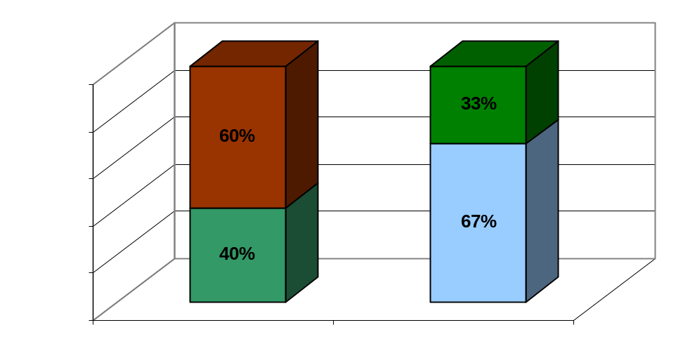
Pensioners
Actives and Deferreds
Assets
Deficit

7.2 In assessing the value of the Scheme’s liabilities above, allowance has been made for asset out-performance as described in Appendix 1, taking into account the investment strategy adopted by the Scheme, as set out in the SIP.

7.3 It is not possible to construct a portfolio of investments which produces a stream of income exactly matching the expected liability outgo. However, it is possible to construct a portfolio which closely matches the liabilities and represents the least risk investment position. Such a portfolio would consist of a mixture of long-term index-linked and fixed interest gilts.

7.4 Investment of NYPF’s assets in line with this notional least risk portfolio would minimise fluctuations in NYPF’s ongoing funding level between successive actuarial valuations.

7.5 However, if, at the Valuation date, NYPF had been invested in this notional portfolio, then in carrying out the Valuation it would not be appropriate to make an allowance for any out-performance of the investments. On this basis (using a lower discount rate) the assessed value of NYPF’s liabilities at the 2010 Valuation would have been significantly higher, by approximately 38% and the declared funding level would be correspondingly reduced to approximately 49%. In addition there would be no prospect of improving the solvency level of NYPF other than by increasing the contribution rates of employers over a sustained period.

7.6 Departure from such a least risk investment strategy, in particular to include equity investments, gives the prospect that out-performance by the relevant assets will, over time, reduce the contribution rate requirements from employers. The Funding Target could therefore in practice be achieved by a combination of employer contributions, investment strategy and investment performance.

Investment Strategy
7.7 The current Investment Strategy, as set out in the SIP, is summarised in the following paragraphs:

General Principles and diversification

7.8 NYPF firmly believes that the emphasis of investment over the long term should be on real assets, particularly equities; these are considered most likely to maximise the long term returns for NYPF. The balance between UK and Overseas equities is, however, a matter of investment judgement. Investment should also be diversified to include other real assets, such as Bonds and Property. At present NYPF has no property holdings but the Committee has agreed to appoint a suitable manager as soon as practicable.

7.9 The neutral benchmark proportions of the various asset classes are determined by NYPF in consultation with the incumbent investment managers together with the Investment Adviser and Investment Consultant and are reviewed at least once every three years to coincide with the Triennial Valuation. The outcome of the latest review of the Investment Strategy is referred to in paragraph 7.11 et seq below.

Risk Budgeting and review of Strategy

7.10 In 2005 and 2006 two Global Fixed Income fund managers were appointed to manage portfolios previously incorporated in ‘Balanced’ mandates and three fund managers previously managing customised global equity mandates took on specialist equity mandates, based upon an assessment of their particular strengths. In addition, a Global Tactical Asset Allocation (GTAA) mandate was established as a means of attempting to capture returns from asset allocation decisions which may have been lost in the shift away from ‘Balanced’ mandates.

7.11 As a result of the periodic review of the Investment Strategy since 2006 a number of small changes to the composition of the Fund have been made. The most significant has been to remove the GTAA mandate from the Fund after its failure to contribute to the investment performance of the NYPF. The latest review, conducted in 2010 and 2011 included an Asset Liability Modelling Study. The results of this review have resulted in some technical changes to the way the Investment Strategy is implemented which are reflected in the revised SIP (updated February 2011).

7.13 In essence, these changes are designed to seek maximum performance from managers by allocating funds for specific asset classes (e.g. bonds, equities) and specialised mandates.

Specific Benchmarks

7.14 NYPF applies specific benchmarks to each investment mandate so as to provide individual investment managers with clearly defined performance targets; in certain cases these are also linked to performance related fee structures. Further details are provided in the Statement of Investment Principles.

7.15 Clearly, these specific benchmarks need to be linked to the assumptions used in the Risk Budgeting exercise and be consistent with those used by the Actuary in the Triennial Valuation. The Funding Strategy adopted by the Actuary for the 2010 Valuation is based on an assumed asset out-performance of 2.5% in respect of liabilities pre-retirement, and 1.0% in respect of post-retirement liabilities (see Appendix 1). Based on the current liability profile of the Scheme this equates to an overall weighted asset out-performance allowance of 1.9% p.a. The Administering Authority believes that this is a reasonable and prudent allowance for asset out-performance that is compatible with the assumptions used in the Risk Budgeting exercise on which the changes to the Investment Strategy, now reflected in the SIP, were based.

7.16 In addition, the Administering Authority has agreed to adopt a more aggressive asset out-performance target of 2.75% when determining the contribution rates of strong covenant employers (see paragraph 6.7). This exceeds the standard out-performance assumption of 6.4% by 0.85%. Therefore a greater level of out-performance by NYPF’s assets is required in order to deliver this additional return assumed by the Actuary (see Appendix 1 paragraph 2.13 et seq).

8.0 IDENTIFICATION OF RISKS AND COUNTER-MEASURES

8.1 The funding of defined benefits is by its nature uncertain. The funding of NYPF has to reflect both financial and demographic assumptions. These assumptions are specified in the Triennial Valuation report of the Actuary. When actual experience is not in line with the assumptions made a surplus or shortfall will emerge at the next Actuarial Valuation and will require a subsequent adjustment to employer contributions to bring the funding back into line with the Funding Target.

8.2 The Administering Authority has been advised by the Actuary that the greatest risk to NYPF’s long term funding objective (i.e. 100% solvency) is the investment risk inherent in the predominantly equity based strategy. Therefore, if the actual asset out-performance between successive valuations diverges adversely from the out-performance currently required on the basis of the 2010 Valuation assumptions, as set out in Appendix 1, this may have a negative effect on the Recovery Plan.

8.3 The chart below shows a “funnel of doubt” funding level graph, which illustrates the range and uncertainty in the future progression of the funding level, relative to the Funding Target adopted in the Valuation. Using a simplified statistical model, the chart shows the probability of exceeding a certain funding level over a 10 year period from the Valuation date. For example, the top line shows the 95th percentile level (i.e. there is a 5% chance of the funding level at each point in time being better than the funding level shown, and a 95% chance of the funding level being lower).

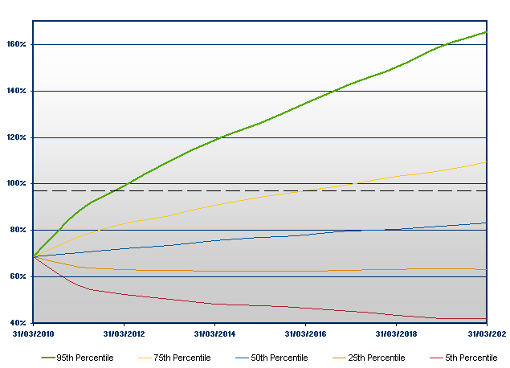
Projected Funding level

8.4 In addition to the asset out-performance risk referred to above, a number of specific risks to the Funding Strategy can be identified. These are summarised below with their appropriate counter measure(s).

Risk | Counter measure
Financial
F1 Investment markets fail to perform in line with expectations | The asset allocation derived from the Investment Strategy is monitored on an ongoing basis and considered quarterly by the Pension Fund Committee (PFC). The Committee receives advice about market conditions (past/present and future) from the Investment Adviser, Investment Consultant and the Treasurer; each investment fund manager also includes a “market commentary” in their quarterly report. If the asset allocation, and the performance generated therefrom, is at odds with the out performance assumption used by the Actuary the Committee has an obligation to consider changing the Investment Strategy.  The Risk Budgeting exercise (referred to in paragraph 7.10) also provided a range of investment market scenarios that the Committee can refer to, and refresh, if it is considering changes to the Investment Strategy.
F2 Market yields move at variance with Valuation/ SIP assumptions

F3 Fund Investment Managers fail to achieve performance targets over the longer term | The performance of individual fund managers is reviewed as part of the quarterly monitoring process referred to in F1/F2 above. Although asset allocation has a greater impact on overall Fund investment performance than that of an individual manager, the PFC reserves the right to amend and/or terminate the mandate of any manager at any time. In considering such action the Committee will take into account the cyclical nature of investment returns and the fact that all managers cannot outperform their benchmark all of the time.
F4 Asset re-allocations in volatile markets may lock in past losses | In reviewing the asset allocation the PFC will take into account best advice regarding future market conditions and not just be reactive to past events. Therefore, any asset reallocation will only be undertaken on the basis of reworking and/or updating the Risk Budgeting model used to establish the Investment Strategy reflected in the SIP.
F5 Pay and price inflation significantly more or less than anticipated | All the assumptions used in the Valuation (see Appendix 1) are monitored on an ongoing basis because they can impact, independently, on the value of assets or the projected costs of liabilities, both of which affect the ongoing solvency position. In practice the pay and price assumptions can only be formally modified at each Triennial Valuation; therefore any significant variation in these two factors between Valuations will be identified by the monitoring process and then discussed with the Actuary as part of the assumption setting for the subsequent Valuation.  The impact of this risk is potentially different for Medium and High Risk employers - see paragraphs 8.5/8.6 below.
F6 Effect of possible increase in employer's contribution rate on service delivery and admitted/scheduled bodies | The Fund has adopted a risk assessment methodology for all employers in the Fund, or wishing to join the Fund in the future - see paragraph 8.5 below
F7 Budget and annual cash surplus not materialising due to shortfall of income or overspending on costs | The PFC approves an annual Income/Expenditure Budget which is reviewed on a quarterly basis. Any unders/overs in levels of anticipated income or projected costs will impact on the projected annual surplus (which is invested as the year progresses) and therefore the Committee will need to consider any remedial action that may be appropriate.  In addition to this budgetary control procedure the Committee also benchmarks its costs against other LGPS Funds.
F8 Monitoring of Solvency level between Triennial Valuations | Because any of the factors identified in the Financial Section of this Risk Table can impinge on the ongoing solvency level, the PFC receives:  - quarterly updates from the Actuary (using current market factors in a pre-set Fund specific model)  - a quarterly comparison of investment performance to date with a notional least risk portfolio  - Annual Interim Valuations.  Whilst these various reports cannot be as comprehensive as the Triennial Valuation they will, taken together, reveal any underlying trends in the solvency level and identify where variances are emerging relative to the assumptions used by the Actuary.

Risk
Demographic
D1 Longevity horizon continues to expand | This is reviewed at each Triennial Valuation by the Actuary. Any abnormal trend for a particular employer will be identified by the Actuary and the employer will have the option to address the consequential funding implications.
D2 Deteriorating pattern of early retirements | The pattern of ill health retirements is monitored at employer level by the PFC on a quarterly basis against the assumptions made by the Actuary in his Valuation.
D3 Strain on the Fund payments relating to early retirements | For early retirements NYPF has a policy that requires an employer to pay into the Fund a single lump sum, or staged payments over 2 to 5 years, equivalent to the financial Strain on the Fund and, if appropriate, augmentation cost created by approving the early retirement. This approach means there is no requirement to address this specific issue as part of the Triennial Valuation process.

Risk | Counter measure
Regulatory
R1 Changes to Regulations, (e.g. more favourable benefits package, potential new entrants to scheme) | NYPF encourages each employer to “sell” the benefits of the LGPS to all its employees.  NYPF ensures that all employers are made aware of the implications (financial or otherwise) of any proposed changes to the Regulations. Employers can then respond to the CLG via the NYPFOG arrangements or individually. The Actuary will identify the impact on the Fund, and/or an individual employer of any Regulation change.  In practice however, it will ultimately be for the employer to fund the cost of any such changes, increased membership levels etc.  NYPF will comply with rule changes and will aim to provide members with accurate information on their circumstances but will not provide financial advice. Employees will, in some cases, need to seek independent financial advice.
R2 Changes to national pension requirements and/or HM Revenue & Customs rules

Risk
Administration
A1 Administering Authority unaware of structural changes in an employer’s membership (e.g. large fall in employee members, large number of retirements) | If the various monitoring arrangements referred to above (e.g. F7, D2) do not proactively identify this issue the reactive position for NYPF is the risk assessment methodology applied to different “types” of employer (see paragraphs 8.5 / 8.6).
A2 Administering authority not advised of an employer closing to new entrants | Depending on the risk category of an employer, NYPF has developed model terms and conditions for inclusion in the Admission Agreement. These terms and conditions are designed to safeguard NYPF against various possible ‘default’ scenarios that may befall an individual employer.
A3 An employer ceasing to exist with insufficient funding or adequacy of a bond
A4 Pension Administration Strategy | In accordance with LGPS (Administration) Regulations 2007 the Administering Authority has prepared and consulted upon a Pension Administration Strategy which includes an agreed set of protocols for the Administering Authority and individual Employers to follow.

Risk
Governance
G1 Frequency of meetings | The Pension Fund Committee (PFC) deals with all aspects of NYPF. The Committee is scheduled to meet a minimum 4 times in each financial year; these meetings are scheduled within 8 weeks of the end of an investment quarter in order to consider the latest performance / monitoring information (see F1, F3, F5, F7, D2). Each meeting has a pre-planned schedule of items although Agendas are flexible to deal with additional matters as they might arise.  In addition to these formal meetings there are a further 6 meetings a year where the Members meet the investment managers to consider performance, strategy, etc.
G2 Member training | The PFC is committed to training for its Members. In addition to a training register, the Committee considers at each meeting any external courses that may be appropriate to Members. In addition in-house training is provided via topic specific workshops. Members also complete the Trustee Knowledge and Understanding Toolkit, a training questionnaire to identify any knowledge gaps that can be addressed through future training events.
G3 Decision procedures | Being a full Committee of North Yorkshire County Council, the PFC is governed by decision making procedures defined in the Constitution of North Yorkshire County Council. These are fully compliant with the terms of the Local Government Act 2000. In addition the PFC will comply with any procedural requirements defined in Scheme Regulations.
G4 Committee membership | The PFC currently comprises:  7 North Yorkshire County Council Members  1 City of York Council Member  1 District Council representative of Local Government North Yorkshire and York  3 Unison Representatives as observers  /cont…
Supported by:
Independent Investment Adviser
Investment Consultant
 | Corporate Director – Strategic Resources (acting as Treasurer to the Fund) | County Council
 | Committee Services
 | Because of the specialised and technical nature of much of the agenda material considered by the Committee, any new Member of the Committee will be expected to undergo training and familiarisation referred to in G2.
 | Under the terms of the LGPS Management and Investment Funds Regulations 2009, the Committee has approved a Governance Policy Statement which will be reviewed on an annual basis, and particularly in the light of `best practice’ guidance published during 2007.
 | Under the same Regulations, the Fund has also published a Communications Policy Statement to reflect its annual Communications Strategy. This is reviewed on an annual basis (see G5 below).
G5 Annual Report | NYPF currently publishes its Final Accounts (in accordance with current Accounting Standards) on an annual basis in a comprehensive Annual Report - the document includes narrative regarding investment performance, the latest Valuation, membership levels, administration issues and governance arrangements.  The Committee will produce an Annual Report for the year 2010/11 in line with proposed ‘best practice’ Guidelines as required under the LGPS (Administration) Regulations 2007.

8.5 In the risk table above a number of references are made to the risk assessment of employer types within NYPF (eg. F5, F6, A1). Apart from the circumstances relating to the valuation of assets and liabilities the implementation of this Funding Strategy, and its implications for the contribution rates of individual employers, needs to have regard to the sustainability of an employer and/or their ability to continue to meet their liabilities within the agreed Funding Strategy.

8.6 The Administering Authority has therefore adopted the following High/Medium/Low risk categorisation of employers.

LOW RISK
Scheduled and resolution bodies as statutory entities that are either required, or can choose to offer membership of the LGPS. This category covers:
- any local authority, or equivalent
- any body which has a funding deficiency guarantee from local or central government

MEDIUM RISK
Scheduled bodies not considered as low risk and admitted bodies with no statutory underpin but:
- a body for which NYPF has a guarantee of liabilities from a local authority (or its equivalent)
- a body which receives funding from local or central government (e.g. colleges and universities)
- a best value type body for which a local authority already within NYPF effectively stands as the ultimate guarantor on the termination of the admission agreement as a result of Regulation 78 (2A)
- can provide satisfactory evidence of financial security (e.g. parent company guarantee, bond, indemnity, insurance)
- is part of a group of related or pooled bodies which share funding on default

HIGH RISK
An admitted body:
- with no external funding guarantee or reserves
- with a known limited lifespan or fixed contract term of admission to NYPF
- which has no active contributors and/or is closed to new joiners
- which relies on voluntary or charitable sources of income

8.7 Each of these risk categories will have a different set of requirements from a NYPF perspective and hence the Administering Authority, and the employers involved, may need to consider alternative approaches to contribution rates, deficit recovery periods and investment strategies either individually or as a group depending on the specific circumstances applying to that employer (or group).

8.8 NYPF will therefore consider the strength of the covenant with each employer and assess the risk accordingly. Thus

- for existing employers with admission agreements this will require a formal review of that agreement with a possible need to renegotiate certain clauses and/or address any omissions

- for any new employers seeking to join NYPF, a model admission agreement is available that fully addresses the risks identified in the table in paragraph 8.6

8.9 In order to facilitate the requirements of individual employers the controlled flexibility policy (paragraph 6.11) has been adopted that allows employers to determine, following consultation with the Administering Authority during the Valuation process, a contribution rate calculated using a shorter deficit recovery period which could be phased over the period to the next Valuation. Alternatively, employers may wish to make lump sum contributions in respect of any deficit to reduce ongoing contribution rates.

9.0 MONITORING AND REVIEW OF THIS STATEMENT

9.1 The Administering Authority has taken advice from the Actuary in preparing this Funding Strategy Statement, and has also consulted with employers during its preparation.
9.2 As a minimum a full review of this Statement will take place every three years, to coincide with the Triennial Valuation by the Actuary. Any review will take account of economic conditions prevailing at the time and will also reflect any legislative changes.

9.3 The Administering Authority will monitor the progress of the Funding Strategy between full actuarial valuations. If considered appropriate, the Funding Strategy will be reviewed (other then as part of the Triennial Valuation process), for example:
- if there has been a significant change in investment market conditions, and/or deviation in the progress of the Funding Strategy
- if there have been significant changes to the fund membership, or Scheme benefits that affect more than one employer
- if there have been changes to the circumstances of any of the employing authorities to such an extent that they impact on or warrant a change in the Funding Strategy
- if there have been any significant special contributions paid into NYPF

10.0 CONTACT DETAILS

10.1 For further details regarding any aspect of this Statement, please contact the Treasurer to the NYPF by one of the following methods:

- telephone – 01609 532192
- email – gary.fielding@northyorks.gov.uk
- correspondence -
c/o Room 4
North Yorkshire County Council
County Hall
Northallerton
North Yorkshire DL7 8AL

APPENDIX 1

Method and Assumptions used in 2010 Actuarial Valuation

1.0 Method

1.1 The actuarial method to be used in the calculation of the Funding Target is the Projected Unit method, under which the salary increases assumed for each member are projected until that member is assumed to leave active service by death, retirement or withdrawal from service. This method implicitly allows for new entrants to the LGPS on the basis that the overall age profile of the active membership will remain stable. As a result, for those employers which are closed to new entrants, an alternative method is adopted (the Attained Age method), which makes advance allowance for the anticipated future ageing and decline of the current closed membership group.

2.0 Principal assumptions

Investment return (discount rate)
2.1 A yield based on market returns on UK Government gilt stocks and other instruments which reflects a market consistent discount rate for the profile and duration of NYPF’s accrued liabilities, plus an Asset Out-performance Assumption (AOA) of 2.5% pa for the pre-retirement period and 1.0% pa post-retirement.

2.2 The AoAs represent the allowance made, in calculating the Funding Target, for the long term additional investment performance of the assets of NYPF relative to the yields available on long dated gilt stocks as at the Valuation date. The allowance for this out-performance is based on the liability profile of NYPF, with a higher assumption in respect of the pre-retirement (i.e. active and deferred pensioner) liabilities than for the post-retirement (ie pensioner) liabilities. This approach thereby allows for a gradual shift in the overall equity/bond weighting in the Investment Strategy as the liability profile of the membership matures over time.

Individual Employers

2.3 Having determined the AOAs as above for the Fund overall, it is important to consider how the financial assumptions impact on individual participating employers. As employers in NYPF will have different mixes of active, deferred and pensioner members, adopting a different pre / post retirement investment return approach is equivalent to hypothecating a different equity/bond mix investment strategy for each employer. Such an approach would be inconsistent with NYPF practice, as set out in this FSS, of allocating investment performance pro rata across all employers based on a “mirror image” investment strategy to the whole Fund. Therefore, in completing the calculations for individual employers, a single, composite, pre and post retirement AoA of 1.9% pa has been calculated which, for NYPF as a whole, gives the same value of the funding target as the separate pre and post retirement AoAs.

Inflation (Consumer Prices Index)
2.4 The inflation assumption will be taken to be the investment market’s expectation for RPI inflation as indicated by the difference between yields derived from market instruments, principally conventional and index-linked UK Government gilts as at the valuation date, reflecting the profile and duration of the Scheme’s accrued liabilities but subject to the following two adjustments.

- an allowance for supply/demand distortions in the bond market is incorporated, and

- an allowance for pensions being increased annually in future by the change in the Consumer Price Index rather than the Retail Price Index, as announced in June 2010. This change will apply from April 2011 and the assumptions make due allowance for this revision as advised by the Actuary

The overall reduction to RPI inflation implied by the investment market at the valuation date is 0.8% per annum.

Salary increases
2.5 The assumption for real salary increases (salary increases in excess of price inflation) will be determined by an allowance of 1.75% pa over the inflation assumption as described above. This includes an allowance for promotional increases.

Pension increases
2.6 Increases to pensions are assumed to be in line with the Inflation (CPI) assumption described above. This is modified appropriately to reflect any benefits which are not fully indexed in line with CPI (eg Guaranteed Minimum Pensions in respect of service prior to April 1997).

Mortality
2.7 The mortality assumptions will be based on the most up-to-date information in relation to self-administered pension schemes published by the Continuous Mortality Investigation (CMI), making allowance for future improvements in longevity and the experience of the scheme. The derivation of the mortality assumption is based on Fund specific analysis. Members who retire on the grounds of ill heath are assumed to exhibit average mortality equivalent to that for a good health retiree at an age 3 years older. For all members, it is assumed that the accelerated trend in longevity seen in recent years will continue in the longer term and as such, the assumptions build in a minimum level of longevity ‘improvement’ year on year in the future in line with the CMI projections subject to a minimum rate of improvement of 1% per annum.

Method and assumptions used in calculating the cost of future accrual

2.8 The cost of future accrual (normal cost) will be calculated using the same actuarial method and assumptions as used to calculate the Funding Target except that the financial assumptions adopted will be as described below.

2.9 The financial assumptions for assessing the future service contribution rate should take account of the following points:
- contributions will be invested in market conditions applying at future dates, which are unknown at the effective date of the Valuation, and which are not directly linked to market conditions at the Valuation date; and
- the future service liabilities for which these contributions will be paid have a longer average duration than the past service liabilities

2.10 The financial assumptions in relation to future service (i.e. the normal cost) are not specifically linked to investment conditions as at the Valuation date itself, but are based on an overall assumed real return (i.e. return in excess of price inflation) of 3.75% per annum, with a long term average assumption for price inflation of 3.0% per annum. These two assumptions give rise to an overall discount rate of 6.75% pa.

2.11 Adopting this approach the future service rate is not subject to variation solely due to different market conditions applying at each successive valuation, which reflects the requirement in the Regulations for stability in the “Common Rate” of contributions. In market conditions at the effective date of the 2010 Valuation this approach gives rise to a somewhat more optimistic stance in relation to the cost of accrual of future benefits compared to the market related basis used for the assessment of the Funding Target.
2.12 At each Valuation the cost of the benefits accrued since the previous Valuation will become a past service liability. At that time any mismatch against gilt yields and the asset out-performance assumptions used for the Funding Target is fully taken into account in assessing the funding position.

Summary of assumptions used for the Funding Target

2.13 The key financial assumptions used for calculating the whole Fund Funding Target and cost of future accrual (the “normal cost”) for the 2010 Valuation is as follows:

 | Assumption | Past Service |  |  | Future Service
 |  | 2010 |  | 2007 | 2010 | 2007
a | Market Implied Inflation (RPI) | 3.8% |  | 3.1% | N/A | N/A
b | Real Index Linked Gilt Yield | 0.7% |  | 1.3% | N/A | N/A
c | Inflation Adjustment* | 0.8% |  | 0.0% | N/A | N/A
d | Inflation** | 3.0% |  | 3.1% | 3.0% | 2.75%
e | Salary Growth | 1.75% |  | 1.75% | 1.75% | 1.75%
 | Asset Out-Performance (AOA)
f | - Pre Retirement | 2.5% |  | 2.0% | N/A | N/A
g | - Post Retirement | 1.0% |  | 0.5% | N/A | N/A
h | Net AOA | 1.9% |  | 1.4% | N/A | N/A
i | Real Return Forecast | N/A |  | N/A | 3.75% | 3.75%
j | Pension Increases = Inflation (d) | 3.0% |  | 3.1% | 3.0% | 2.75%
k | Salary Increases = Inflation + Salary growth (d + e) | 4.75% |  | 4.85% | 4.75% | 4.5%
l | Fixed Interest Gilt Yields = Market Implied Inflation (RPI) + Real Index Linked Gilt Yield  (a + b) | 4.5% |  | 4.4% | N/A | N/A
 | Required Investment Return
m | - Pre-Retirement (f + l) | 7.0% | 6.4% |  | 6.75% | 6.5%
n | - Post Retirement (g + l) | 5.5% |  | 4.9% | 6.75% | 6.5%
o | - Pre and Post Retirement (h + l) | 6.4% |  | 5.8% | = Inflation + Real Return Forecast
 | Investment Offset Assumptions
p | Improved Investment Return (IIR) | 0.85% |  | 1.35% | N/A | N/A
q | Total Investment Return including IIR (o + p) | 7.25% |  | 7.15% | N/A | N/A
r | AOA (h + p) | 2.75% |  | 2.75% | N/A | N/A

* The inflation adjustment allows for both the inclusion of an Inflation Risk Premium (IRP) and the decision to link pensions to CPI rather than RPI.
** Therefore inflation at 2010 is an assumption for future CPI, whereas at 2007 it was an assumption for future RPI. For past service inflation is derived as (a – c), for future service inflation is a long term assumption, not directly related to current market yields.

Assumptions used in calculating contributions payable under the Recovery Plan

  - The contributions payable under the Recovery Plan are calculated using the same assumptions as those used to calculate the Funding Target (row o, paragraph 2.13), with the exception that, for certain employers, the required contributions are adjusted to allow for the following variation in assumptions during the period of the Recovery Plan.

Investment return on existing assets and future contributions

  - An overall return effective as at the Valuation date of 2.75% pa (over the liabilities) for strong covenant employers reflecting the underlying Investment Strategy of NYPF and, in particular, including the assets of the scheme that underlie the pensioner as well as the non-pensioner liabilities (see paragraph 7.16).

  - This overall additional effective return (2.75%) is assessed relative to the liabilities consistent discount rate, and is based upon the assumptions that the Fund continues to invest a significant proportion of assets in return seeking investments over the duration of the recovery period.

  - The total required investment return then is the liability yield consistent with the assumed liability discount rate of the Fund at the Valuation Date (4.5%pa) plus the overall additional investment return assumption of 2.75%pa which produces a required investment return from the assets of 7.25% pa effective as at the Valuation date. This can be compared with the current rate of return required to meet the assumptions used by the Actuary in determining the funding target for the Fund’s and all other employers’ liabilities of 6.4%.

Key | Assumption | Investment Offset Assumption | Actuarial Liability Assumption
a | Liability Discount Rate | 4.5% | 4.5%
b | Overall Investment Return Assumption | 2.75% | -
c | Average Asset Out-Performance Assumption for funding target | - | 1.9%
d | Required Investment Return | 7.25% | 6.4%
 |  | (a+b) | (a+c)

2.18 The investment return assumed for the contributions under the Recovery Plan is taken to apply throughout the recovery period. As a result, any change in Investment Strategy which would act to reduce the expected future investment returns could invalidate these assumptions and therefore the Funding Strategy.

2.19 The above variation to assumptions in relation to the Recovery Plan can only be applied for those employers which the Administering Authority deems to be of sufficiently high covenant (paragraph 6.5) to support the anticipation of investment returns, based on the current Investment Strategy, over the entire duration of the Recovery Plan period. No such variation in the assumptions will apply in the case of any employer which does not have a funding deficit at the Valuation (and therefore for which no Recovery Plan is applicable). Where the variation in the assumptions does apply, the resultant total employer contribution rate implemented following the 2010 Valuation will be subject to a minimum of the normal future service contribution rate for the employer concerned.
APPENDIX 2

3.0 RESULTS OF THE 2010 ACTUARIAL VALUATION

3.1 The results of the 2010 actuarial Valuation are shown below:

Line | Component | @ 31/3/07 | @ 31/3/10 | + / − %
a | Market Value of assets £m | 1265.7 | 1344.6 | +6.2
 | Past Service Liabilities
 | active - accrued | 855.6 | 884.7 | + 3.4
 | deferred | 288.6 | 317.3 | + 9.9
 | pensioners | 723.4 | 802.0 | + 10.9
b | £m | 1867.6 | 2004 | + 7.3
a-b | Past Service deficit £m | 601.9 | 659.4 | + 9.6
a / b | Funding level % | 67.8 | 67.1

3.2 The same information expressed in the form of an employer contribution rate for the Whole Fund is as follows

Component | @ 31/3/07  % | @ 31/3/10  %
Cost of ongoing accrual (i.e. future liabilities of current members) | 18.7 | 18.5
− Employees contributions | - 6.4 | -6.3
= Future service contribution rate | 12.3 | 12.2
+ Deficit recovery contributions | 6.5 | 6.4
= Required Employer Contribution rate for the Whole Fund | 18.8 | 18.6

APPENDIX F

Communications Policy Statement
February 2013

If you require this information in an alternative language or another format such as large type, audio cassette or Braille, please contact the Pensions Help & Information Line on 01609 536335

INDEX
Section Content
1 Background
2 Objectives
3 Stakeholders
4 Methods of Communication
5 Annual Communications Strategy
6 Key Policy / Strategy documents
7 Review of this Policy Statement
8 Further information

COMMUNICATIONS POLICY STATEMENT

1.0 BACKGROUND

1.1 All Local Government Pension Scheme (LGPS) Funds in England and Wales
are required to publish a Statement under the LGPS (Amendment) (No 2)
Regulations 2005 relating to the Communications Strategy for the Fund.

1.2 The key requirements for preparing the Statement are summarised as follows:
(a) the Administering Authority will prepare, publish and review a policy
statement setting out its communication strategy for communicating with
members, members’ representatives, prospective members and
employing authorities; and for the promotion of the Scheme to
prospective members and their employing authorities.
(b) the statement must be revised and published whenever there is a
material change in the policy.

1.3 North Yorkshire County Council (NYCC) as the administering authority for the
North Yorkshire Pension Fund (NYPF) has published this Statement in
accordance with these Regulations. This Statement has been prepared in
consultation with appropriate interested parties.

2.0 OBJECTIVES

2.1 The Fund’s objectives in communicating with stakeholders (as defined in
Section 3 below) are:
- to keep all stakeholders informed about the management and administration of the NYPF
- to inform stakeholders to enable them to make the decisions they need to make regarding pensions and the NYPF
- to consult major stakeholders on changes to regulations, policies and procedures that affect the NYPF
- to promote the Local Government Pension Scheme as an important tool in recruitment and as a benefit to scheme members
- to use the most effective ways of communicating with stakeholders
- to seek continuous improvement in the way we communicate

2.2 The Fund also needs to ensure that Stakeholders find it easy and convenient
to communicate with the Fund.

3.0 STAKEHOLDERS

3.1 The key stakeholders for the NYPF are:
- the County Council’s Pension Fund Committee who make decisions about the way the Pension Fund and pension benefits are managed and administered
- the Advisory Panel of employer representatives and other stakeholders which has been established to advise the Pension Fund Committee on policy matters as well as provide a scrutiny function
- scheme employers who use the scheme to help recruit, retain and support employees and who themselves contribute to the Fund
- scheme members (current contributors, deferred and retired members) and their representatives who are ultimately the recipients of the benefits of the pension scheme
- prospective scheme members who are eligible to benefit from the scheme but have not yet joined
- staff employed by the County Council and other employers who are responsible for the management and operation of the Pension Fund and pension benefits

3.2 Other stakeholders who contribute to the NYPF include –
- the Fund Actuary
- the Investment Adviser
- the Investment Consultant
- the Independent Professional Observer
- investment managers
- the asset custodian
- the AVC provider
- the Fund Solicitor

3.3 Because the stakeholders referred to in paragraph 3.2 above are the
providers of services to the Fund, it is important that communication with them
exists both to and from the Fund. Thus they must be made aware of changes
affecting the Fund as well as have the ability and the means to provide advice /
feedback, etc, to the Fund.

4.0 METHODS OF COMMUNICATION

4.1 There are a variety of methods of communication adopted by the Fund. These
are identified below with reference to each of the key stakeholders listed in
Section 3 above.

4.2 The items marked with an * are available on the NYPF website.

Pension Fund Committee
4.3 The following are used to provide information to Committee Members:
- agenda papers – these are prepared for each Committee meeting and cover all matters (ie benefit administration and investment of the Fund’s assets) relating to policy and performance of the Fund
- newsletters* - Committee Members receive copies of all newsletters issued by NYPF
- workshops – organised for specific purposes usually linked to the review of a major piece of NYPF policy (eg Investment Strategy)
- third party training sessions – details are circulated to all Members on a regular basis

Advisory Panel
4.4 The Panel receives the same information as provided to Committee members (see paragraph 4.3 above)

Scheme Employers
4.5 The following will be provided to all Scheme Employers:
- newsletter* – updates delivered electronically
- technical material – any information connected with the Scheme and its administration is issued to Employer nominated liaison officer(s)
- consultation – opportunities for NYPF/Employer consultation wherever a collaborative approach is appropriate or policy changes are proposed or required
- website – including discrete area for ‘employer only’ information
- Pension Fund Officer Group (NYPFOG) – twice yearly meetings held between NYPF and Employer representatives
- one to one employer meetings – dealing with any matters arising between NYPFOG meetings including training employers’ staff engaged in pension administration activities
- Employers Guide* – detailing pension administration processes
- Pensions Administration Strategy* – agreed protocol setting out the respective responsibilities of NYCC (as the administering authority of the Fund) and the Fund’s Employers
- Communications Strategy* and Annual Communications Plan* setting out the current communication arrangements and future developments
- Employer access to employee data – a means of providing data on line including starters, leavers, amendments and contributions
- Admission Agreements – provide advice, process management and data analysis for any prospective employer pursuing admitted body status

Scheme Members
4.6 The following will be provided to active, deferred and retired members –
- Scheme Guide (short guide)* – downloaded by new members of the Scheme or provided in hard copy on request by employers
- Scheme Guide (full)* - provided on request
- Membership Certificate (Statutory Notice) – confirmation of participation in the LGPS following the commencement of employment
- estimate of benefits* – provided on request or calculated by members online
- annual benefit statement* – provided on-line for active and deferred members or can be provided in hard copy on request
- newsletter* – twice per year for active and once per year for retired members
- pre-retirement courses – participation in employer led courses as required up to 6 times per year
- membership data on-line* – personal data available to active and deferred members subject to applying for a personal identification number
- road shows/information sessions/attendance at relevant events – ad hoc in co-operation with Scheme employers
- satisfaction surveys – conduct surveys for qualitative assessments on such matters as payment of retirement benefits, satisfaction with call-handling etc
- pay advice (sent to pensioners)
- replies to any correspondence by letter, e-mail or fax
- helpline – contact available via telephone during office hours or voicemail out of office hours
- website – including online benefits calculator and other self-service facilities

Prospective Scheme Members
4.7 The following will be available to prospective members:
- Scheme Guide (short guide)* - distributed via the employers to all new employees or downloaded from the website
- road shows / events - in co-operation with Scheme employers
- direct promotion – will assist the employer in promoting the Scheme via employer communication systems eg pay advice, newsletters, induction seminars, etc
- helpline – contact available via telephone during office hours or voicemail out of office hours
- website – including Scheme guides to the LGPS

5.0 ANNUAL COMMUNICATIONS STRATEGY (incorporating Action Plan)

5.1 In consultation with Scheme employers and other stakeholders, via the
Advisory Panel and NYPFOG, the County Council prepares an Annual
Communications Strategy for the NYPF detailing the current arrangements
for communication with its stakeholders together with future communication
developments. The Communications Strategy is subject to annual review and
is presented to the Pension Fund Committee for approval at the start of each
financial year.

5.2 The Strategy includes the following -
- commentary on current operating context for the Fund
- progress on actions included in previous Annual Strategy
- details of proposed actions for next year with costs
- details of any Satisfaction Surveys undertaken in previous year and proposed for next year

6.0 KEY POLICY / STRATEGY DOCUMENTS

6.1 In addition to the range of documents produced by the Fund explaining the
benefits of the LGPS, for Scheme members and employers (see paragraphs
4.5 to 4.7 above), the Fund publishes a number of other key documents relating to the administration and governance of the Fund. These are as follows -
- Funding Strategy Statement (FSS)
- Statement of Investment Principles (SIP)
- Annual Report
- Annual Communications Strategy + related Action Plan
- Pensions Administration Strategy
- Governance Compliance Statement

6.2 All of these documents are available on the NYPF website.

7.0 REVIEW OF THIS POLICY STATEMENT

7.1 The Policy Statement will be reviewed annually to coincide with the approval of
the Annual Communications Strategy as referred to in Section 5.

8.0 FURTHER INFORMATION

8.1 If you would like to know more about our communications, or have a query
about any aspect of the North Yorkshire Pension Fund, you can contact us in
the following ways:
in writing
North Yorkshire Pension Fund
County Hall
Northallerton
North Yorkshire
DL7 8AL
by telephone
Pensions Help and Information Line
01609 536335
by email
pensions@northyorks.gov.uk

8.2 Further information can also be found on the NYPF website at
http.www.nypf.org.uk

A responsive County Council providing quality and efficient local services
APPENDIX G
121

Rates and Adjustments Certificate issued in accordance with Regulation 36 of the Administration Regulations

Name of Fund | North Yorkshire Pension Fund

Primary Contribution Requirements

I hereby certify that, in my opinion, the common rate of employers’ contributions payable in each year of the period of three years beginning 1 April 2011 should be at the rate of 12.2 per cent of Pensionable Pay.

I hereby certify that, in my opinion, the amount of the employers’ contributions payable in each year of the period of three years beginning with 1 April 2011, as set out above, should be individually adjusted as set out in the attached schedule.

Contributions will be payable monthly in arrears with each payment normally being due by the 19th of the following month. Pensionable Pay is pay as determined under the LGPS regulations for the calculation of employee contributions.

Further Adjustments

A further individual adjustment shall be applied in respect of each non-ill health early retirement occurring in the period of three years covered by this certificate. This further individual adjustment will be calculated in accordance with methods agreed from time to time between the Fund’s actuary and the Administering Authority.

The contributions set out in the attached schedule represent the minimum contribution which may be paid by each employer. Additional contributions may be paid if requested by the employer concerned.

The contributions may be varied as agreed by the Actuary and Administering Authority to reflect any changes in contribution requirements as a result of any benefit costs being insured against a third party.

In cases where an element of an existing Scheme employer's deficit is transferred to a new employer on its inception, the Scheme employer's deficit recovery contributions, as shown on the schedule to this Certificate in Appendix I, may be reallocated between the Scheme employer and the new employer to reflect this, on advice of the Actuary and as agreed with the Administering Authority.

Regulation 36(8)

No allowance for non-ill health early retirements has been made in determining the results of the valuation, on the basis that the costs arising will be met by additional contributions. Allowance for ill health retirements has been included in each employer’s contribution rate, on the basis of the method and assumptions set out in the report.

Signature 

Name Ian Kirk

Qualification Fellow of the Institute of Actuaries

Date of signing 31 March 2011

