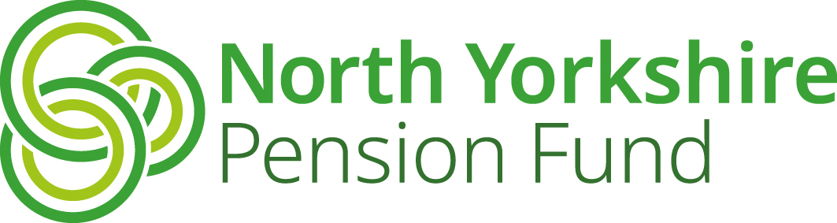

A
Independent Registered Medical Practitioner Form

North Yorkshire Pion Fun
Name of Practitioner | Click to enter name
Organisation requiring  Practitioner’s services | Click to enter name of organisation

I confirm that I am ‘an independent registered medical practitioner (“IRMP”) qualified in occupational health medicine’.

An ‘independent registered medical practitioner (‘IRMP’) qualified in occupational health medicine’ means a practitioner who is registered with the General Medical Council and

- holds a diploma in occupational health medicine (D Occ Med) or an equivalent qualification issued by a competent authority in an EEA state; and for the purposes of this definition, ‘competent authority’ has the meaning given by section 55(1) of the Medical Act 1983( );

or

(b) is an Associate, a Member or a Fellow of the Faculty of Occupational Medicine or an equivalent institution of an EEA state.

Practitioner’s signature

Date | Click to enter date
GMC reference number | Click to enter reference number

Please email this form to pensions@northyorks.gov.uk

Or return by post to:
North Yorkshire Pension Fund, County Hall, Northallerton, DL7 8AL

