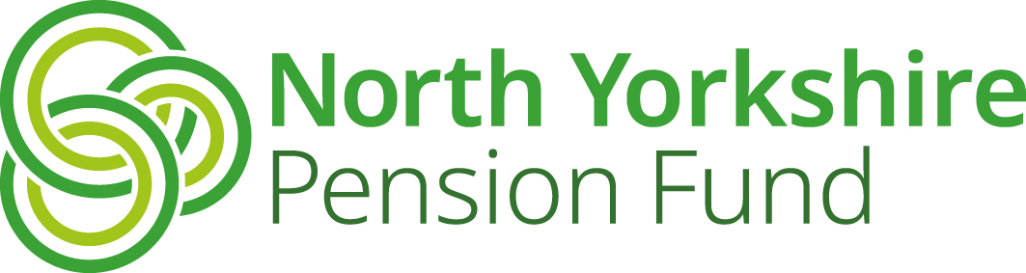

**A**

|  |
| --- |
| **Independent Registered Medical Practitioner Form** |

**North Yorkshire Pion Fun**

|  |  |
| --- | --- |
| Name of Practitioner | Click to enter name |
| Organisation requiring  Practitioner’s services | Click to enter name of organisation |

**I confirm that I am ‘an independent registered medical practitioner (“IRMP”) qualified in occupational health medicine’.**

An ‘independent registered medical practitioner (‘IRMP’) qualified in occupational health medicine’ means a practitioner who is registered with the General Medical Council and

1. holds a diploma in occupational health medicine (D Occ Med) or an equivalent qualification issued by a competent authority in an EEA state; and for the purposes of this definition, ‘competent authority’ has the meaning given by section 55(1) of the Medical Act 1983( );

**or**

(b) is an Associate, a Member or a Fellow of the Faculty of Occupational Medicine or an equivalent institution of an EEA state.

|  |  |
| --- | --- |
| Practitioner’s signature |  |
| Date | Click to enter date |
| GMC reference number | Click to enter reference number |

**Please email this form to** [pensions@northyorks.gov.uk](mailto:pensions@northyorks.gov.uk)

Or return by post to**:**

North Yorkshire Pension Fund, County Hall, Northallerton, DL7 8AL